**GOVERNMENT COLLEGE OF**

**ENGINEERING TIRUNELVELI - 627 007.**



**2022-2023**



**Register**

**Number: 950820104022**



**CERTIFICATE**



**This**

**is**

**a**

**bonafide**

**record**

**of**

**work**

**done**

**by………………………………………………...........**

**……………………………………………………….Government College of Engineering, Tirunelveli**

**during**

**the**

**year**

**2022**

**-**

**2023.**

**Place: Tirunelveli**

**Tirunelveli**

**Date:**



**Staff**

**In**

**-**

**charge:**



**Head**

**of**

**the**

**Department**

**Submitted for the Anna University Practical Examination held at Government College of Engineering, Tirunelveli on……………………………………….**

**Internal Examiner External Examiner**

**GOVERNMENT COLLEGE OF**

**ENGINEERING TIRUNELVELI - 627 007.**



A MINI-PROJECT REPORT

ON

**“STOCK MAINTENANCE SYSTEM”**

Submitted by

**KEERTHIKA S - 950820104022**

**Department of Computer Science & Engineering.**

**Government College of Engineering, Tirunelveli.**

**2020-2024**

# ACKNOWLEDGEMENT

It is my great pleasure to acknowledge the assistance and contribution of the individuals who co- operated us to complete the project work successfully. First and foremost, I wish to express my deep gratitude and thanks to our project guide, for the enthusiastic guidance and helping in successful completion of project work. They provided us their precious time for valuable suggestions and encouragement throughout the work. It is for their patience, guidance and encouragement at all time that this work has shaped us the way it is. A project is Team work and reflects the contribution of many people. A number people contributed their time and efforts in making their project work a Success. We would like to thank everyone who contributed their time and efforts to help in completing the project work.

# OBJECTIVE

* Stock maintenance is an interface between the customer and the sales person. It aims at improving the efficiency in maintaining the stocks.

**TABLE OF CONTENT**

**STOCK MAINTENANCE SYSTEM**

|  |  |  |  |  |  |  |  |
| --- | --- | --- | --- | --- | --- | --- | --- |
| **Expt .No** | **Date** | | **Name of Experiment** | | **Page No.** | **Marks Awarded** | **Master’s**  **Initial** |
| 1 | 16/08/22 | | IDENTIFICATION OF SYSTEM SOFTWARE | | 5 |  |  |  |  |
| 2 | 23/08/22 | | SOFTWARE REQUIREMENTS SPECIFICATION | | 6 |  |  |  |  |
| 3 | 30/08/22 | | USECASE DIAGRAM | | 8 |  |  |  |  |
| 4 | 06/09/22 | | CLASS DIAGRAM | | 11 |  |  |  |  |
| 5 | 13/09/22 | | SEQUENCE DIAGRAMS AND COLLABORATION DIAGRAMS | | 14 |  |  |  |  |
| 6 | 20/09/22 | | STATE CHART AND ACTIVITY DIAGRAM | | 17 |  |  |  |  |
| 7 | 27/09/22 | | DEPLOYMENT DIAGRAM | | 19 |  |  |  |  |
| 8 | 04/10/22 | | COMPONENT DIAGRAM | | 20 |  |  |  |  |
| 9 | 11/10/22 | | USER INTERFACE LAYER | | 21 |  |  |  |  |
| 10 | 18/10/22 | | DATABASE LAYER | | 26 |  |  |  |  |
| 11 | 25/10/22 | | DOMAIN LAYER | | 27 |  |  |  |  |
| 12 | 01/11/22 | | TEST CASE SCENARIOS | | 74 |  |  |  |  |
| 13 | 08/11/22 | | INCREASE THE REUSABILITY AND MAINTAINABILITY OF THE SYSTEM SOFTWARE | | 76 |  |  |  |  |
| 14 | 29/11/22 | | IMPLEMENT MODIFIED SYSTEM AND TEST IT VARIOUS SCENARIOS | | 77 |  |  |  |  |
|  | |  | |

|  |  |
| --- | --- |
| EX No:1 Date: 16/08/22 | IDENTIFICATION OF SYSTEM SOFTWARE |

**AIM:**

To write a problem statement for Stock maintenance system.

**PROBLEM STATEMENT:**

The stock maintenance system which takes care of sales information of the company and analyze the potential of the trade. It maintains the data in efficient manner. The existing system was recorded manually on pen and paper and time consuming one. To overcome this, we are operating it in system and database for delivering accurate and real time information on stocks. This is also helps in calculating the total stocks, pending stocks and updating. It is mainly used in business sector to maintain stock level and profit and unprofitable product. This is mainly used by sales person and customers. This system is used for time and money saving, increases productivity and efficiency and also used for accurate data analysis of stocks. Also used for analysis the data in real-time requirements of the stocks.

**RESULT:**

Thus the problem statement for Stock maintenance system was written.

# 

|  |  |
| --- | --- |
| EX No:2 Date: 23/08/22 | SOFTWARE REQUIREMENTS SPECIFICATION |

# AIM:

To write a software requirements specification for Stock maintenance system.

**INTRODUCTION:**

The main objective of the documentation is to illustrate the requirements of project Stock maintenance system The requirements of project documentation gives the detailed description of both functional and non-functional requirements. It will also explain about the features of the interface system will react to external stimuli.

**SCOPE:**

* The system provides an interface to the customer where they can fill in orders for the items needed.
* The sales person is concerned with the issues of items and can use this system.
* Provide a communication platform between the customer and the sales person.

**REQUIREMENTS:**

# FUNCTIONAL REQUIREMENTS

**CUSTOMER REGISTRATION:**

* + SMS provides customer registration and status information to the administration to view their status.
  + Stock maintenance system provides automatic customer register number generated based on randomization algorithm.
  + Stock maintenance system provides to customer to purchase product and enlist them in the profile.

**PRODUCT MANAGEMENT:**

* Easily track product information.
* Quickly produce reports for single or multiple sold products.

# NON-FUNCTIONAL REQUIREMENTS:

1. Offer – Offer given by merchant

2. Carting – Mark and select multiple books

# HARDWARE REQUIREMENTS

1. Processor – Intel Core i3
2. Hardware – 40 gb (segate)
3. Ram – 512 mb
4. DVD Ram – 1 nos

**TOOLS USED**

**SOFTWARE REQUIREMENTS**

1. OS **-** windows 11.
2. FRONT END TOOL- Java swing.
3. BACK END TOOL - NetBeans IDE 8.2.

**TECHNOLOGIES TO BE USED**

1. HTML – Markup language used for creating web pages.
2. CSS – Cascading style sheets used to style web pages
3. JAVASCRIPT – Scripting language used as part of web browsers, whose implementation allow client side script to interact with the user, control the browser and communicate asynchronously.
4. J2EE – Java 2 Enterprise Edition is a programming platform for developing and running distributed java applications.
5. HTTP – Hyper Text Transfer Protocol.
6. IP/TCP – Internet Protocol is the communication protocol used to connect hosts on the internet.

**RESULT:**

Thus the SRS document for Stock maintenance system was written.

|  |  |
| --- | --- |
| EX No:3 Date: 30/08/22 | USECASE DIAGRAM |

**AIM:**

To draw a use case diagram for Stock maintenance system.

**DESCRIPTION:**

A Use case diagram is a way to summarize the details of a system and the users within the system. It is used to represent the Goal of the system provide the model of flow of events and interaction. A use case diagram consists of the boundary, actors, use case and the relationships between actors and use case. A use case model can be developed by the steps below

* Identify the actors of the system.
* Identify roles of each other.
* Create the use cases for every goal.
* Structure the users.
* Prioritize review and estimate the uses

**PROCEDURE:**

This diagram will contain the actors, use cases which are given below

**ACTORS**:

1. User
2. Administrator
3. Supplier

**USE CASE**:

1. Login
2. Register
3. Search stock
4. Payment
5. Supplier
6. Update Stock

**EXPLANATION**

* **ADMINISTRATOR:** The administrator will have the control over the registration details of each users and they have to verify the login credentials. They can add a stock by giving the stock the following attributes: id and stock name. They can also update the user details as well as the stock details.
* **REGISTERED USER:** The registered user can login into the application and search for a stock. If they want to purchase it then they should actually pay for it and make it available offline. They can search the stock using the id and product name. The result should contain the list of stocks which matches the search parameter. The payment can have different options like google pay, paytm , bank transactions etc.
* **REGISTER**: The new user can register their name, email id and password.
* **LOGIN**: The registered admin and user can login using email or username and password.
* **SEARCH STOCK**: User can search for a particular stock using id and stock name .
* **PAYMENT:** If a user wants to purchase a particular stock they have to pay for it using any of the online payment mode.
* **SUPPLIER:** The supplier will supply the product that are requested by the admin.

* **UPDATE STOCK:** The admin can add new Stocks if the user requests any new stocks.

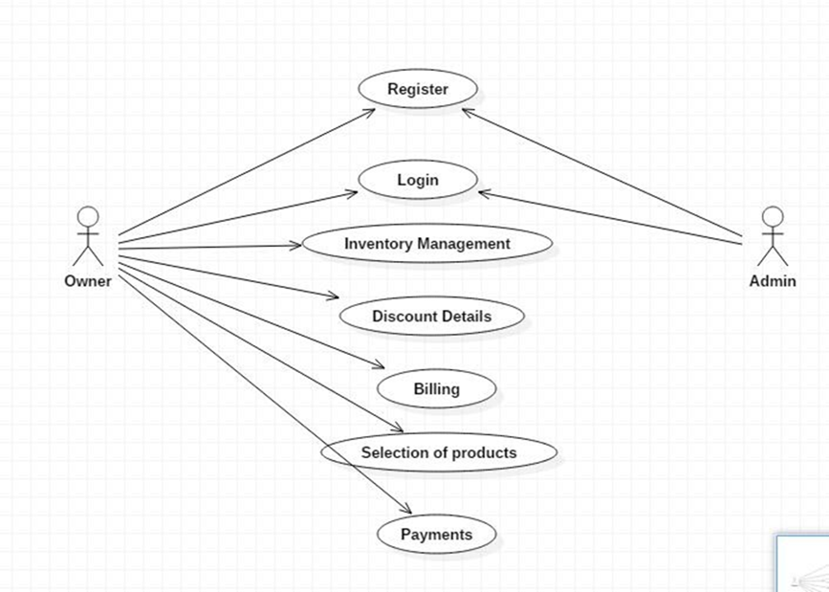

**RESULT:**

Thus the use case diagram for Stock maintenance system was drawn and output was verified.

|  |  |
| --- | --- |
| EX No: 4 Date: 06/09/22 | CLASS DIAGRAM |

**AIM**:

To draw a class diagram for Stock maintenance system.

**PROCEDURE:**

The Class diagram depicts the static view of an application. It represents the types of objects residing in the system and the relationships between them. It resembles a flowchart which classes are portrayed as boxes each box having three rectangles inside. The top rectangle contains the name of the class the middle rectangle contains the attributes of the class, the lower rectangle contains the methods to draw a class diagram,

* Identify the class names
* Distinguish relationship
* Create the structure

**NOTATIONS:**

* Association
* Dependency
* Inheritance
* Aggregation
* Realization
* Composition
* Implementation

Four basic type of relationship are;

**i.** **Communicates ( ):**

An actor is connected to the use case using a link with no arrow heads.

**ii. Includes (<------):**

An use case contains a behaviors that is common to more than one other use case the arrow points common use case

**iii.Extends (---->):**

A different use case handles exception from the basic use case. Thearrow points from the extended to the basic use case.

**iv.Generalizes:**

One UML thing is more general than the other thing. The arrow points tothe general thing.

**DESCRIPTION:**

A class diagram in the Unified Modelling Language is a type of static structure diagram that describes the structures of the system by showing the classes, their attributes, operations and the relationship among the object**.** The Stock maintenance system consists of five classes:

1. Login
2. Registered user
3. Administrator
4. Stock
5. Payment

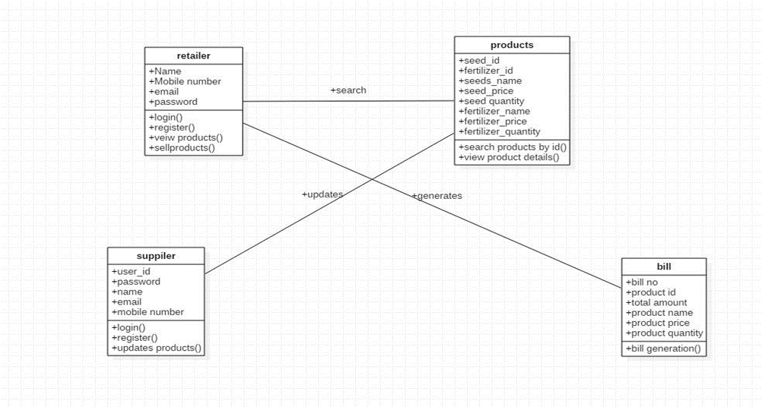

* **LOGIN:** Login to the system.
* **REGISTERED USER:** It consists of four attributes and four operations. The attributes are username, password, email id, phone no. The operations of this class are login(), search(), register().
* **ADMINISTRATOR:** It consists of two attributes and two operations. The attributes are password, email id. The operations are update(), record().
* **STOCK:** It consists of four attributes and two operations. The attributes are Stock name, stock id , quantity and price. The operations are update(), add().
* **PAYMENT:** It consists of three attributes and two operations. The attributes are stock id, stock name, quantity and price. The operations of this class are search(), bill().
* **LOGOUT:** Logout from the system.

**RESULT:**

Thus the class diagram for Stock maintenance system was drawn and described successfully.

|  |  |
| --- | --- |
| EX No: 5 Date: 13/09/22 | **SEQUENCE DIAGRAMS AND COLLABORATION DIAGRAMS** |

**AIM:**

To draw and describe a sequence and collaboration diagram for Stock maintenance system.

**SEQUENCE DIAGRAM:**

A sequence diagram shows object interactions arranged in time sequence. A sequence diagram shows, as parallel vertical lines(lifelines), different processes or objects that live simultaneously and as horizontal arrows, the messages exchanged between them, in the order in which they occur.

**SEQUENCE DIAGRAM FOR STOCK MAINTENANCE SYSTEM:**

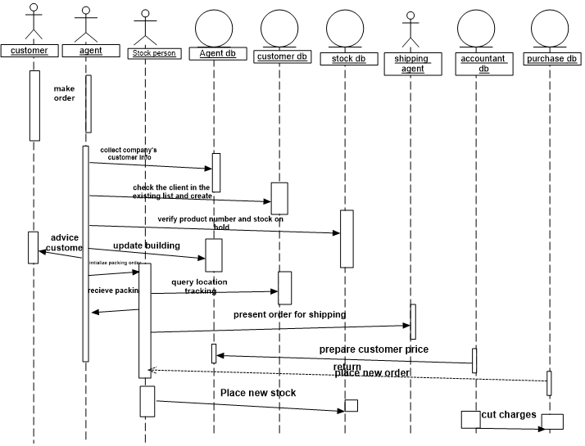

* **REGISTERED USER:** The registered user requests for login to the administrator and once the login is granted to the registered user, they can search for a particular stock in the database and if he wants to purchase the book he should send the payment details to the administrator and then can purchase it.
* **SUPPLIER:** The supplier requests the admin to add a particular stock, the admin then update the book in the database and send the success message to the user.

**COLLABORATION DIAGRAM:**

A Collaboration diagram, also known as a communication diagram, is an illustration of the relationships and interactions among software objects in the Unified Modelling Language (UML).

**COLLABORATION DIAGRAM FOR STOCK MAINTENANCE SYSTEM:**

The collaboration diagram here represents the same information as the sequence diagram. Here the visitor seeks for login to the administrator, once the registration is successful, the visitor can search for a particular stock in the database and database will display the stock. The registered user can seek for login to the administrator, once the administrator agreed the login. The registered user can search for a particular stock in the database. The database will check the availability of the stock and display the stock. The user can further send the payment successful message to the administrator and the administrator will verify it and give access to purchase the stock. The user requests to add a stock to the administrator, the administrator update the book in database and send a success message to user. Then admin will send the stock details to supplier and then supplier will give stocks to admin and admin will add the details to the admin panel of database and user will be notified after that update.

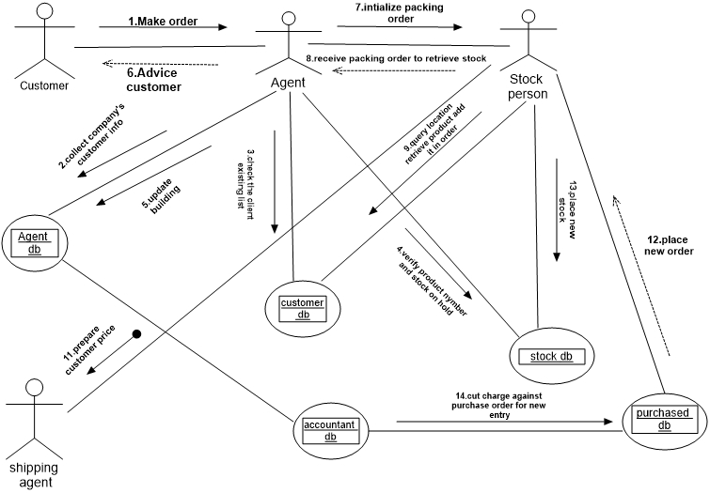

**RESULT:**

Thus the UML sequence and collaboration diagrams are drawn and described successfully.

|  |  |
| --- | --- |
| EX No: 6 Date: 20/09/22 | STATE CHART AND ACTIVITY DIAGRAM |

# 

**AIM:**

To draw a state chart and activity diagram for Stock maintenance system.

**STATE CHART:**

A state chart diagram describes a state machine. State machine can be defined as a machine which defines different states of an object and these states are controlled by external or internal events. State chart diagram describes the flow of control from one state to another state. States are defined as a condition in which an object exists and it changes when some event is triggered.

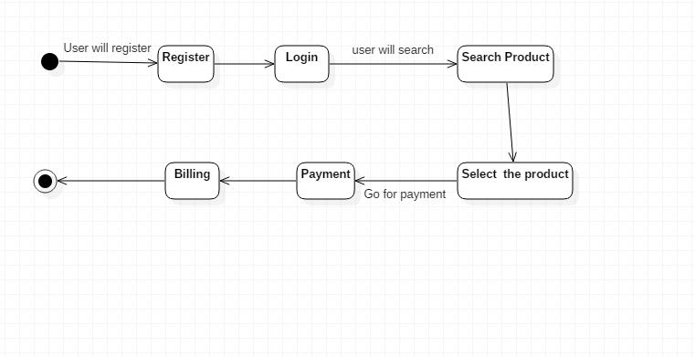

**ACTIVITY DIAGRAM:**

Activity diagram is generally used to describe the flow of different activities and actions**.** The activity diagram is used to demonstrate the flow of control within the system rather than the implementation. It models the concurrent and sequential activities. The activity diagram helps in envisioning the workflow from one activity to another. It put emphasis on the condition of flow and the order in which it occurs. The flow can be sequential, branched or unbranched and deal with such kinds of flows, the activity diagram has come up with a fork, join etc.

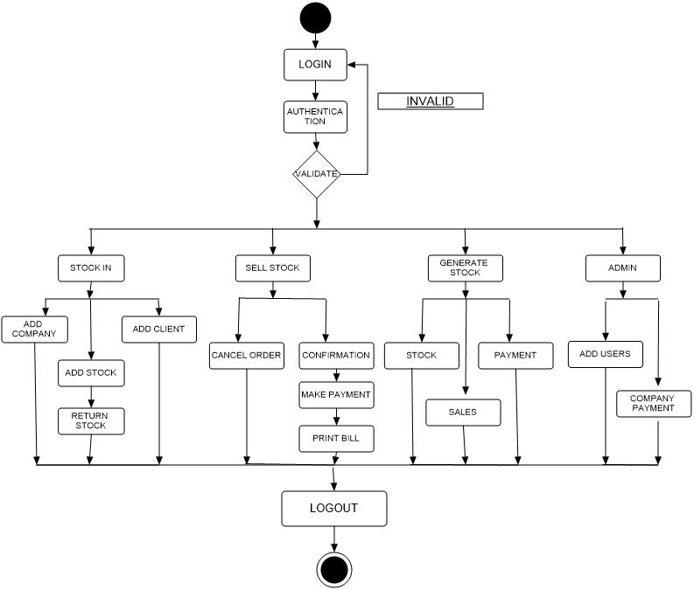

**RESULT:**

Thus the state chart and activity diagram for Stock maintenance system was drawn and described successfully.

|  |  |
| --- | --- |
| EX No: 7 Date: 27/09/22 | **DEPLOYMENT DIAGRAM** |

**AIM:**

To Identify the conceptual classes and develop a Domain Model for the Stock maintenance system.

**DEPLOYMENT DIAGRAM:**

The deployment diagram shows the structure of the runtime system. It shows the configuration of runtime processing elements and the software components that live in them. They are usually used in conjunction with deployment diagrams to show how physical modules of code are distributed on the system.

**STOCK MAINTENANCE SYSTEM:**

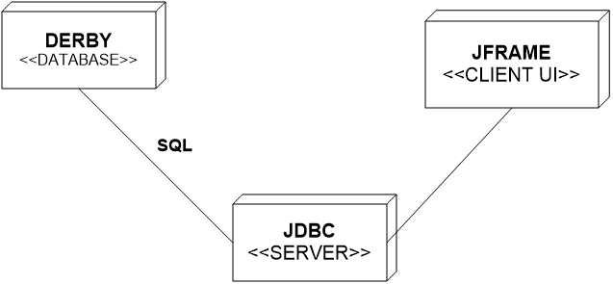

**RESULT:**

Thus the Deployment diagram of the Stock maintenance system has been drawn Successfully.

|  |  |
| --- | --- |
| EX No: 8 Date: 04/10/22 | **COMPONENT DIAGRAM** |

**AIM:**

To Identify the conceptual classes and develop a Domain Model for the Stock maintenance system.

**COMPONENT DIAGRAM:**

These are organizational parts of a UML model. These are boxes to which a model can be decomposed. They show the structure of the code itself. They model the physical components such as source code, user interface in a design. It is similar to the concept of packages

**STOCK MAINTENANCE SYSTEM:**

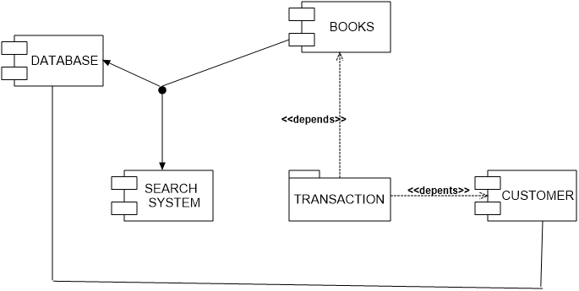

**RESULT:**

Thus the Component diagram of the Stock maintenance system has been drawn Successfully.

# 

|  |  |
| --- | --- |
| EX No: 9 Date: 11/10/22 | USER INTERFACE LAYER |

**AIM:**

To implement user interface layer of Stock maintenance system.

**RETAILER FORM**

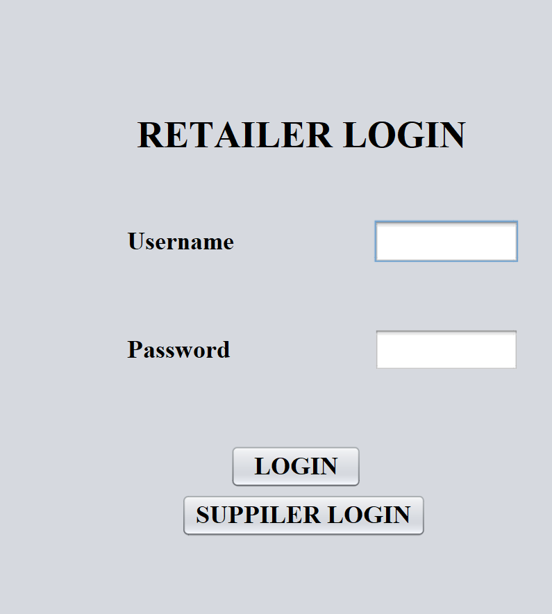

**DESCRIPTION:**

The Stock maintenance System form is the front page of the system. It consists of two Jbuttons Login and Supplier login. The login button will lead to the main page once clicked, where the we can search , add and update the stock using the Items name .Using the supplier button, we will redirected to supplier login page.

**SUPPLIER FORM**

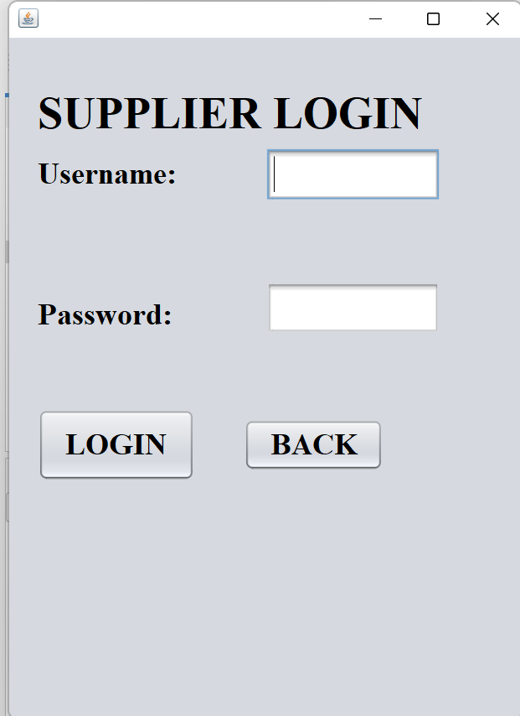

**DESCRIPTION:**

The Stock maintenance System form is the front page of the supplier system. It consists of two Jbuttons Login and back. The login button will lead to the main page once clicked, where the we can search , add and update the stock using the Items name .Using the back button, we will redirected to retailer login page.

**MAIN FROM 1**

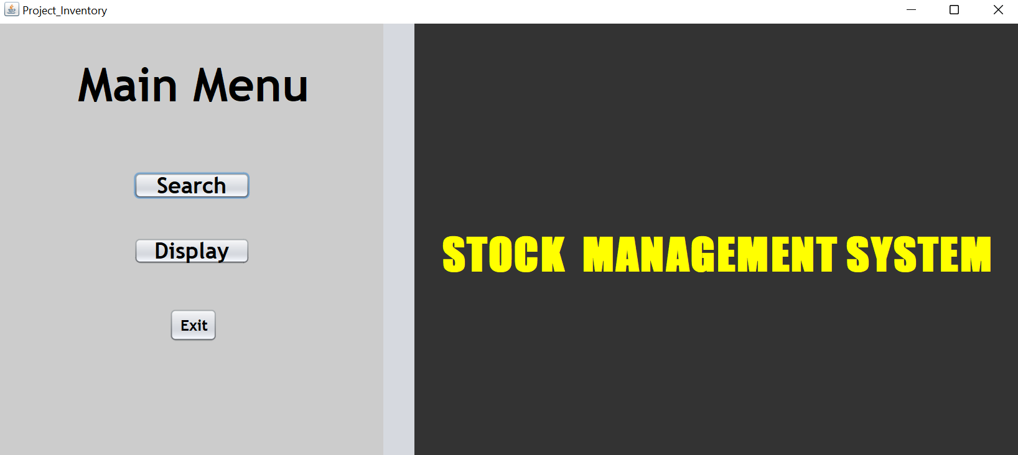

**DESCRIPTION:**

The Stock maintenance System form is the front page of the system. It consists of two Jbuttons Search login and Display. The search button will lead to the search page once clicked, where the we can search the stock using the Items name and using that we can find where the stock is present or not. Using the exit button, we will exit the whole stock maintenance system.

**ADD/DELETE PAGE:**

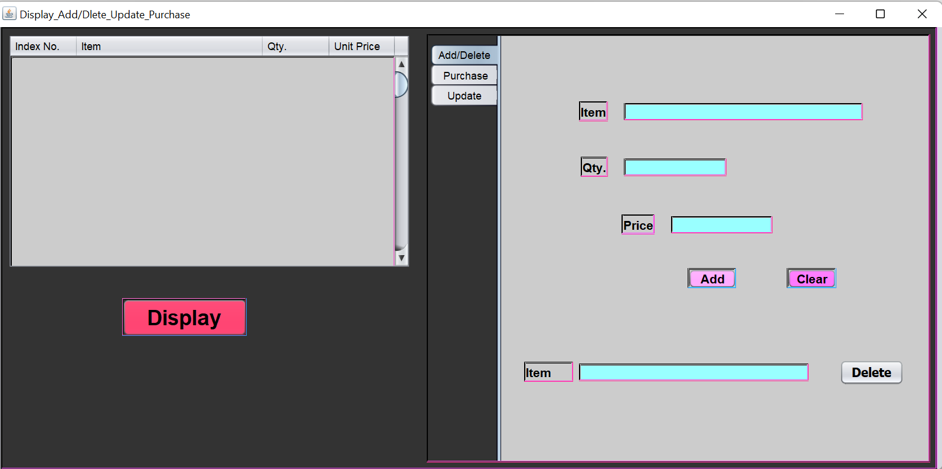

**DESCRIPTION:**

This the page which is redirected while pressing display button, using this we can add/update , purchase and update . using display button the whole items in the stock will be displayed. The delete stock can be performed using the item name of the stock. For adding the items using name of stock , quantity and the price of the stock.

**UPDATE PAGE:**

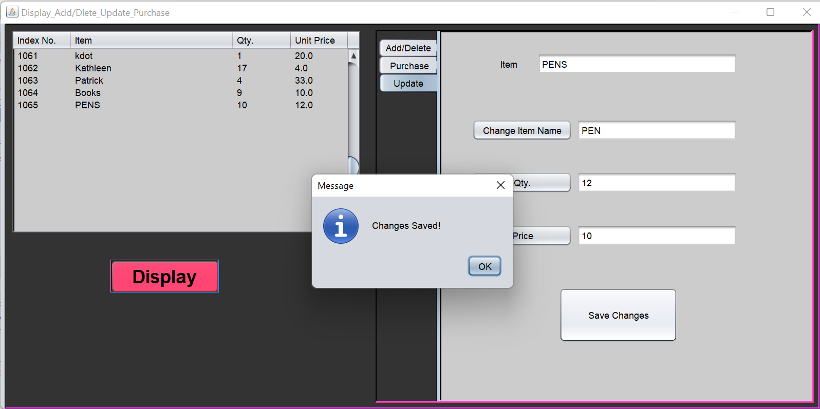

**DESCRIPTION:**

The update page will update the data which is present in the stock already using this we can update the quantity, price and change the stock name. After updating the po up notification will be notified as Changes Saved!. This indicates the update have saved successfully. It contains save changes button to save the updates. Using display button we can refresh the stock and we will be able to see the updated items.

**PURCHASE FORM:**

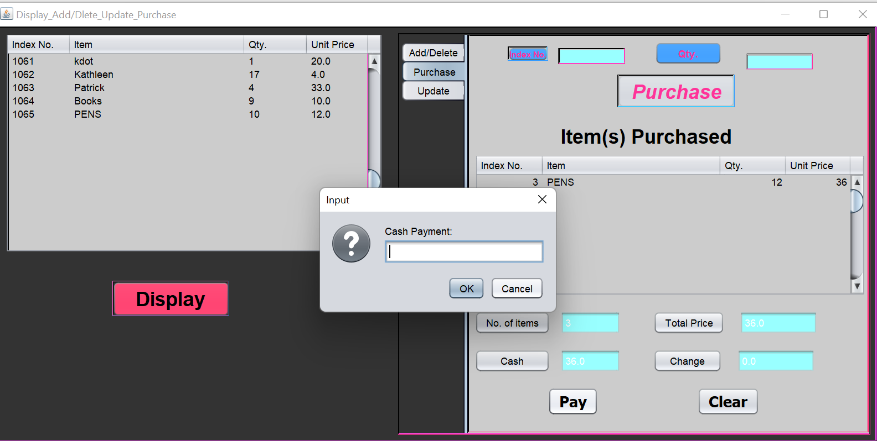

**DESCRIPTION:**

This payment or purchase form will display when the customer wants to buy particular stock and the payment process will notify after completing the purchase. Using pay button will able to purchase the stock.

For purchasing we must know the name of the stock.

**SEARCH FORM:**

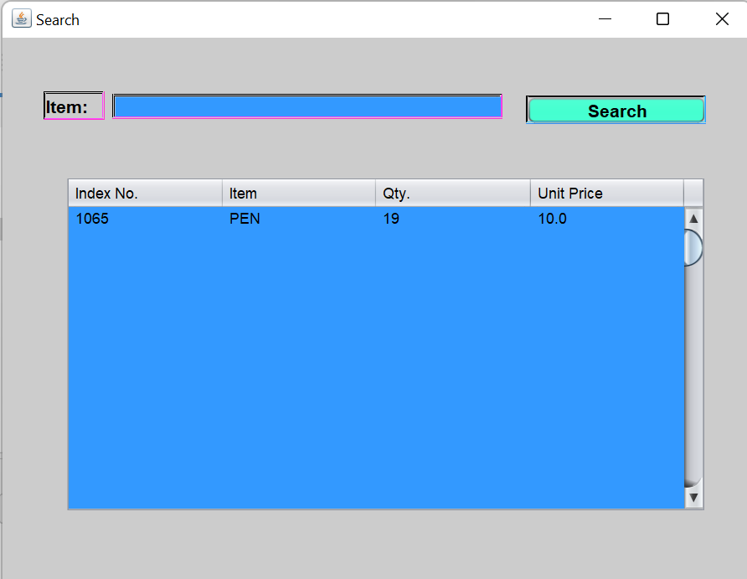

**DESCRIPTION:**

Using this we will be able to search the stock present in the stock system or not. For searching we can find the stock using name of the stock.

**RESULT:**

Thus, the user interface layer forms are designed, implemented and the snapshots are taken successfully.

|  |  |
| --- | --- |
| EX No: 10 Date: 18/10/22 | **DATABASE LAYER** |

**AIM:**

To implement the database layer of Stock maintenance system.

**USER DETAILS:**

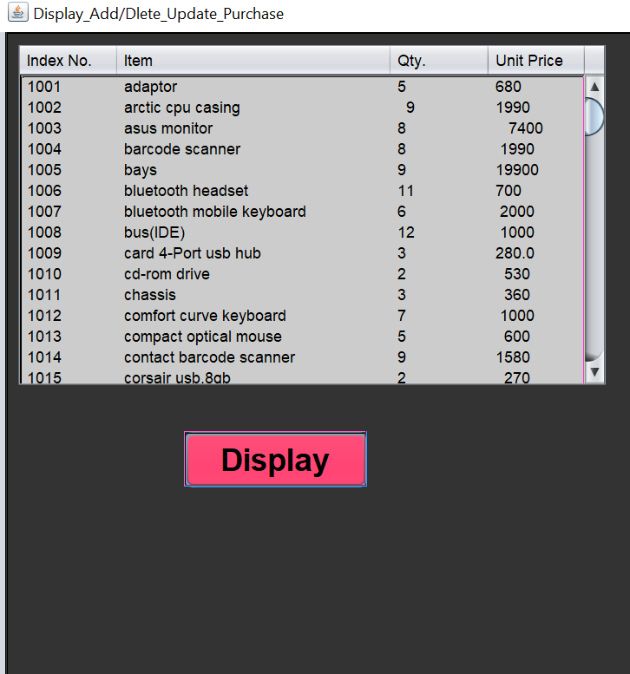

**DESCRIPTION:**

This, is the stock details present in the stock. It consists of four column Index no, Item, Qty and price of the stock. It will represent the all the data contain in the stock system. Using this we can find what all stocks are present in the system using this a user can have a brief information for knowing the stock details.

**RESULT:**

Thus, the database layer of Stock maintenance system was designed, implemented and the snapshots were taken successfully.

|  |  |
| --- | --- |
| EX No: 11 Date: 25/10/22 | **DOMAIN LAYER** |

**AIM:**

To implement the domain layer of Stock maintenance system.

**FRONT FORM:**

/*

* To change this template, choose Tools | Templates

* and open the template in the editor.

*/

/**

*

* @author acer

*/

import java.io.*;

import javax.swing.*;

public class Inventory extends javax.swing.JFrame {

/**

* Creates new form Inventory

*/

public Inventory() {

initComponents();

}

/**

* This method is called from within the constructor to initialize the form.

* WARNING: Do NOT modify this code. The content of this method is always

* regenerated by the Form Editor.

*/

@SuppressWarnings("unchecked")

// <editor-fold defaultstate="collapsed" desc="Generated Code">

private void initComponents() {

jPanel1 = new javax.swing.JPanel();

jButton1 = new javax.swing.JButton();

jButton3 = new javax.swing.JButton();

jButton5 = new javax.swing.JButton();

jLabel1 = new javax.swing.JLabel();

jPanel2 = new javax.swing.JPanel();

jLabel2 = new javax.swing.JLabel();

setDefaultCloseOperation(javax.swing.WindowConstants.EXIT_ON_CLOSE);

setTitle("Project_Inventory");

setBackground(new java.awt.Color(102, 102, 255));

setCursor(new java.awt.Cursor(java.awt.Cursor.DEFAULT_CURSOR));

jPanel1.setBackground(new java.awt.Color(204, 204, 204));

jButton1.setFont(new java.awt.Font("Trebuchet MS", 1, 24)); // NOI18N

jButton1.setText("Search");

jButton1.setBorder(null);

jButton1.addActionListener(new java.awt.event.ActionListener() {

public void actionPerformed(java.awt.event.ActionEvent evt) {

jButton1ActionPerformed(evt);

}

});

jButton3.setFont(new java.awt.Font("Trebuchet MS", 1, 24)); // NOI18N

jButton3.setText("Display");

jButton3.setBorder(null);

jButton3.addActionListener(new java.awt.event.ActionListener() {

public void actionPerformed(java.awt.event.ActionEvent evt) {

jButton3ActionPerformed(evt);

}

});

jButton5.setFont(new java.awt.Font("Trebuchet MS", 1, 16)); // NOI18N

jButton5.setText("Exit");

jButton5.setBorder(null);

jButton5.addActionListener(new java.awt.event.ActionListener() {

public void actionPerformed(java.awt.event.ActionEvent evt) {

jButton5ActionPerformed(evt);

}

});

jLabel1.setBackground(new java.awt.Color(255, 255, 255));

jLabel1.setFont(new java.awt.Font("Trebuchet MS", 1, 50)); // NOI18N

jLabel1.setText(" Main Menu");

javax.swing.GroupLayout jPanel1Layout = new javax.swing.GroupLayout(jPanel1);

jPanel1.setLayout(jPanel1Layout);

jPanel1Layout.setHorizontalGroup(

jPanel1Layout.createParallelGroup(javax.swing.GroupLayout.Alignment.LEADING)

.addGroup(javax.swing.GroupLayout.Alignment.TRAILING, jPanel1Layout.createSequentialGroup()

.addGap(0, 71, Short.MAX_VALUE)

.addComponent(jLabel1, javax.swing.GroupLayout.PREFERRED_SIZE, 284, javax.swing.GroupLayout.PREFERRED_SIZE)

.addGap(59, 59, 59))

.addGroup(jPanel1Layout.createSequentialGroup()

.addGroup(jPanel1Layout.createParallelGroup(javax.swing.GroupLayout.Alignment.LEADING)

.addGroup(jPanel1Layout.createSequentialGroup()

.addGap(146, 146, 146)

.addGroup(jPanel1Layout.createParallelGroup(javax.swing.GroupLayout.Alignment.LEADING)

.addComponent(jButton3, javax.swing.GroupLayout.PREFERRED_SIZE, 125, javax.swing.GroupLayout.PREFERRED_SIZE)

.addComponent(jButton1, javax.swing.GroupLayout.PREFERRED_SIZE, 125, javax.swing.GroupLayout.PREFERRED_SIZE)))

.addGroup(jPanel1Layout.createSequentialGroup()

.addGap(184, 184, 184)

.addComponent(jButton5, javax.swing.GroupLayout.PREFERRED_SIZE, 52, javax.swing.GroupLayout.PREFERRED_SIZE)))

.addContainerGap(javax.swing.GroupLayout.DEFAULT_SIZE, Short.MAX_VALUE))

);

jPanel1Layout.setVerticalGroup(

jPanel1Layout.createParallelGroup(javax.swing.GroupLayout.Alignment.LEADING)

.addGroup(jPanel1Layout.createSequentialGroup()

.addGap(36, 36, 36)

.addComponent(jLabel1)

.addGap(64, 64, 64)

.addComponent(jButton1)

.addGap(41, 41, 41)

.addComponent(jButton3)

.addGap(47, 47, 47)

.addComponent(jButton5, javax.swing.GroupLayout.PREFERRED_SIZE, 36, javax.swing.GroupLayout.PREFERRED_SIZE)

.addContainerGap(130, Short.MAX_VALUE))

);

jPanel2.setBackground(new java.awt.Color(51, 51, 51));

jLabel2.setFont(new java.awt.Font("Impact", 1, 48)); // NOI18N

jLabel2.setForeground(new java.awt.Color(255, 255, 0));

jLabel2.setText("STOCK MANAGEMENT SYSTEM");

javax.swing.GroupLayout jPanel2Layout = new javax.swing.GroupLayout(jPanel2);

jPanel2.setLayout(jPanel2Layout);

jPanel2Layout.setHorizontalGroup(

jPanel2Layout.createParallelGroup(javax.swing.GroupLayout.Alignment.LEADING)

.addGroup(jPanel2Layout.createSequentialGroup()

.addGap(29, 29, 29)

.addComponent(jLabel2)

.addContainerGap(29, Short.MAX_VALUE))

);

jPanel2Layout.setVerticalGroup(

jPanel2Layout.createParallelGroup(javax.swing.GroupLayout.Alignment.LEADING)

.addGroup(javax.swing.GroupLayout.Alignment.TRAILING, jPanel2Layout.createSequentialGroup()

.addContainerGap(javax.swing.GroupLayout.DEFAULT_SIZE, Short.MAX_VALUE)

.addComponent(jLabel2, javax.swing.GroupLayout.PREFERRED_SIZE, 237, javax.swing.GroupLayout.PREFERRED_SIZE)

.addGap(105, 105, 105))

);

javax.swing.GroupLayout layout = new javax.swing.GroupLayout(getContentPane());

getContentPane().setLayout(layout);

layout.setHorizontalGroup(

layout.createParallelGroup(javax.swing.GroupLayout.Alignment.LEADING)

.addGroup(layout.createSequentialGroup()

.addComponent(jPanel1, javax.swing.GroupLayout.PREFERRED_SIZE, javax.swing.GroupLayout.DEFAULT_SIZE, javax.swing.GroupLayout.PREFERRED_SIZE)

.addPreferredGap(javax.swing.LayoutStyle.ComponentPlacement.RELATED, 33, Short.MAX_VALUE)

.addComponent(jPanel2, javax.swing.GroupLayout.PREFERRED_SIZE, javax.swing.GroupLayout.DEFAULT_SIZE, javax.swing.GroupLayout.PREFERRED_SIZE)

.addGap(0, 0, 0))

);

layout.setVerticalGroup(

layout.createParallelGroup(javax.swing.GroupLayout.Alignment.LEADING)

.addComponent(jPanel1, javax.swing.GroupLayout.Alignment.TRAILING, javax.swing.GroupLayout.DEFAULT_SIZE, javax.swing.GroupLayout.DEFAULT_SIZE, Short.MAX_VALUE)

.addComponent(jPanel2, javax.swing.GroupLayout.DEFAULT_SIZE, javax.swing.GroupLayout.DEFAULT_SIZE, Short.MAX_VALUE)

);

pack();

}// </editor-fold>

private void jButton1ActionPerformed(java.awt.event.ActionEvent evt) {

Search a= new Search();

a.setVisible(true);

a.setDefaultCloseOperation(Search.DISPOSE_ON_CLOSE);

}

private void jButton3ActionPerformed(java.awt.event.ActionEvent evt) {

Display_Purchase a= new Display_Purchase();

a.setVisible(true);

a.setDefaultCloseOperation(Display_Purchase.DISPOSE_ON_CLOSE);

}

private void jButton5ActionPerformed(java.awt.event.ActionEvent evt) {

int exit=JOptionPane.showConfirmDialog(null, "ARE YOU SURE YOU WANT TO EXIT?");

if(exit==0){

JOptionPane.showMessageDialog(null, "Thank You :)");

System.exit(0);

}

}

/**

* @param args the command line arguments

*/

public static void main(String args[]) {

/*

* Set the Nimbus look and feel

*/

//<editor-fold defaultstate="collapsed" desc=" Look and feel setting code (optional) ">

/*

* If Nimbus (introduced in Java SE 6) is not available, stay with the

* default look and feel. For details see

* http://download.oracle.com/javase/tutorial/uiswing/lookandfeel/plaf.html

*/

try {

for (javax.swing.UIManager.LookAndFeelInfo info : javax.swing.UIManager.getInstalledLookAndFeels()) {

if ("Nimbus".equals(info.getName())) {

javax.swing.UIManager.setLookAndFeel(info.getClassName());

break;

}

}

} catch (ClassNotFoundException ex) {

java.util.logging.Logger.getLogger(Inventory.class.getName()).log(java.util.logging.Level.SEVERE, null, ex);

} catch (InstantiationException ex) {

java.util.logging.Logger.getLogger(Inventory.class.getName()).log(java.util.logging.Level.SEVERE, null, ex);

} catch (IllegalAccessException ex) {

java.util.logging.Logger.getLogger(Inventory.class.getName()).log(java.util.logging.Level.SEVERE, null, ex);

} catch (javax.swing.UnsupportedLookAndFeelException ex) {

java.util.logging.Logger.getLogger(Inventory.class.getName()).log(java.util.logging.Level.SEVERE, null, ex);

}

//</editor-fold>

/*

* Create and display the form

*/

java.awt.EventQueue.invokeLater(new Runnable() {

public void run() {

new Inventory().setVisible(true);

}

});

}

// Variables declaration - do not modify

private javax.swing.JButton jButton1;

private javax.swing.JButton jButton3;

private javax.swing.JButton jButton5;

private javax.swing.JLabel jLabel1;

private javax.swing.JLabel jLabel2;

private javax.swing.JPanel jPanel1;

private javax.swing.JPanel jPanel2;

// End of variables declaration

}

**DISPLAY FORM:**

import java.io.*;

import javax.swing.*;

public class Display_Purchase extends javax.swing.JFrame {

/**

* Creates new form Display_Purchase

*/

public Display_Purchase() {

initComponents();

}

/**

* This method is called from within the constructor to initialize the form.

* WARNING: Do NOT modify this code. The content of this method is always

* regenerated by the Form Editor.

*/

@SuppressWarnings("unchecked")

// <editor-fold defaultstate="collapsed" desc="Generated Code">

private void initComponents() {

jButton1 = new javax.swing.JButton();

jLabel4 = new javax.swing.JLabel();

jToggleButton1 = new javax.swing.JToggleButton();

jPanel1 = new javax.swing.JPanel();

jScrollPane1 = new javax.swing.JScrollPane();

jTable1 = new javax.swing.JTable();

jButton2 = new javax.swing.JButton();

jTabbedPane1 = new javax.swing.JTabbedPane();

jPanel2 = new javax.swing.JPanel();

jLabel1 = new javax.swing.JLabel();

jLabel2 = new javax.swing.JLabel();

jLabel3 = new javax.swing.JLabel();

jTextField3 = new javax.swing.JTextField();

jTextField4 = new javax.swing.JTextField();

jTextField5 = new javax.swing.JTextField();

jButton5 = new javax.swing.JButton();

jButton6 = new javax.swing.JButton();

jButton7 = new javax.swing.JButton();

jTextField14 = new javax.swing.JTextField();

jLabel7 = new javax.swing.JLabel();

jPanel4 = new javax.swing.JPanel();

jScrollPane2 = new javax.swing.JScrollPane();

jTable2 = new javax.swing.JTable();

jButton12 = new javax.swing.JButton();

jButton13 = new javax.swing.JButton();

jTextField10 = new javax.swing.JTextField();

jTextField11 = new javax.swing.JTextField();

jButton14 = new javax.swing.JButton();

jButton15 = new javax.swing.JButton();

jTextField12 = new javax.swing.JTextField();

jTextField13 = new javax.swing.JTextField();

jButton16 = new javax.swing.JButton();

jButton17 = new javax.swing.JButton();

jButton3 = new javax.swing.JButton();

jButton4 = new javax.swing.JButton();

jTextField1 = new javax.swing.JTextField();

jTextField2 = new javax.swing.JTextField();

jButton18 = new javax.swing.JButton();

jLabel6 = new javax.swing.JLabel();

jPanel5 = new javax.swing.JPanel();

jTextField6 = new javax.swing.JTextField();

jButton9 = new javax.swing.JButton();

jButton10 = new javax.swing.JButton();

jButton11 = new javax.swing.JButton();

jTextField7 = new javax.swing.JTextField();

jTextField8 = new javax.swing.JTextField();

jTextField9 = new javax.swing.JTextField();

jLabel5 = new javax.swing.JLabel();

jButton8 = new javax.swing.JButton();

jButton1.setText("jButton1");

jLabel4.setText("jLabel4");

jToggleButton1.setText("jToggleButton1");

setDefaultCloseOperation(javax.swing.WindowConstants.EXIT_ON_CLOSE);

setTitle("Display_Add/Dlete_Update_Purchase");

jPanel1.setBackground(new java.awt.Color(51, 51, 51));

jPanel1.setBorder(javax.swing.BorderFactory.createBevelBorder(javax.swing.border.BevelBorder.RAISED, new java.awt.Color(0, 0, 0), new java.awt.Color(255, 51, 255)));

jTable1.setBackground(new java.awt.Color(204, 204, 204));

jTable1.setBorder(new javax.swing.border.SoftBevelBorder(javax.swing.border.BevelBorder.RAISED, new java.awt.Color(0, 0, 0), new java.awt.Color(255, 51, 204)));

jTable1.setModel(new javax.swing.table.DefaultTableModel(

new Object [][] {

{null, null, null, null},

{null, null, null, null},

{null, null, null, null},

{null, null, null, null},

{null, null, null, null},

{null, null, null, null},

{null, null, null, null},

{null, null, null, null},

{null, null, null, null},

{null, null, null, null},

{null, null, null, null},

{null, null, null, null},

{null, null, null, null},

{null, null, null, null},

{null, null, null, null},

{null, null, null, null},

{null, null, null, null},

{null, null, null, null},

{null, null, null, null},

{null, null, null, null},

{null, null, null, null},

{null, null, null, null},

{null, null, null, null},

{null, null, null, null},

{null, null, null, null},

{null, null, null, null},

{null, null, null, null},

{null, null, null, null},

{null, null, null, null},

{null, null, null, null},

{null, null, null, null},

{null, null, null, null},

{null, null, null, null},

{null, null, null, null},

{null, null, null, null},

{null, null, null, null},

{null, null, null, null},

{null, null, null, null},

{null, null, null, null},

{null, null, null, null},

{null, null, null, null},

{null, null, null, null},

{null, null, null, null},

{null, null, null, null},

{null, null, null, null},

{null, null, null, null},

{null, null, null, null},

{null, null, null, null},

{null, null, null, null},

{null, null, null, null},

{null, null, null, null},

{null, null, null, null},

{null, null, null, null},

{null, null, null, null},

{null, null, null, null},

{null, null, null, null},

{null, null, null, null},

{null, null, null, null},

{null, null, null, null},

{null, null, null, null},

{null, null, null, null},

{null, null, null, null},

{null, null, null, null},

{null, null, null, null},

{null, null, null, null},

{null, null, null, null},

{null, null, null, null},

{null, null, null, null},

{null, null, null, null},

{null, null, null, null},

{null, null, null, null},

{null, null, null, null},

{null, null, null, null},

{null, null, null, null},

{null, null, null, null},

{null, null, null, null},

{null, null, null, null},

{null, null, null, null},

{null, null, null, null},

{null, null, null, null},

{null, null, null, null},

{null, null, null, null},

{null, null, null, null},

{null, null, null, null},

{null, null, null, null},

{null, null, null, null},

{null, null, null, null},

{null, null, null, null},

{null, null, null, null},

{null, null, null, null},

{null, null, null, null},

{null, null, null, null},

{null, null, null, null},

{null, null, null, null},

{null, null, null, null},

{null, null, null, null},

{null, null, null, null},

{null, null, null, null},

{null, null, null, null},

{null, null, null, null}

},

new String [] {

"Index No.", "Item", "Qty.", "Unit Price"

}

) {

boolean[] canEdit = new boolean [] {

false, false, false, false

};

public boolean isCellEditable(int rowIndex, int columnIndex) {

return canEdit [columnIndex];

}

});

jTable1.getTableHeader().setReorderingAllowed(false);

jScrollPane1.setViewportView(jTable1);

if (jTable1.getColumnModel().getColumnCount() > 0) {

jTable1.getColumnModel().getColumn(0).setPreferredWidth(10);

jTable1.getColumnModel().getColumn(1).setPreferredWidth(150);

jTable1.getColumnModel().getColumn(2).setResizable(false);

jTable1.getColumnModel().getColumn(2).setPreferredWidth(10);

jTable1.getColumnModel().getColumn(3).setPreferredWidth(10);

}

jButton2.setBackground(new java.awt.Color(255, 51, 102));

jButton2.setFont(new java.awt.Font("Vani", 1, 24)); // NOI18N

jButton2.setText("Display");

jButton2.setBorder(javax.swing.BorderFactory.createBevelBorder(javax.swing.border.BevelBorder.RAISED, null, new java.awt.Color(0, 0, 0), new java.awt.Color(51, 153, 255), null));

jButton2.addActionListener(new java.awt.event.ActionListener() {

public void actionPerformed(java.awt.event.ActionEvent evt) {

jButton2ActionPerformed(evt);

}

});

jTabbedPane1.setBackground(new java.awt.Color(51, 204, 255));

jTabbedPane1.setBorder(javax.swing.BorderFactory.createBevelBorder(javax.swing.border.BevelBorder.RAISED, new java.awt.Color(0, 0, 0), new java.awt.Color(255, 51, 153)));

jTabbedPane1.setForeground(new java.awt.Color(255, 51, 102));

jTabbedPane1.setTabPlacement(javax.swing.JTabbedPane.LEFT);

jPanel2.setBackground(new java.awt.Color(204, 204, 204));

jLabel1.setBackground(new java.awt.Color(51, 51, 51));

jLabel1.setFont(new java.awt.Font("Vani", 1, 14)); // NOI18N

jLabel1.setText("Item");

jLabel1.setBorder(javax.swing.BorderFactory.createBevelBorder(javax.swing.border.BevelBorder.RAISED, new java.awt.Color(0, 0, 0), new java.awt.Color(255, 51, 153)));

jLabel2.setBackground(new java.awt.Color(51, 51, 51));

jLabel2.setFont(new java.awt.Font("Vani", 1, 14)); // NOI18N

jLabel2.setText("Qty.");

jLabel2.setBorder(javax.swing.BorderFactory.createBevelBorder(javax.swing.border.BevelBorder.RAISED, new java.awt.Color(0, 0, 0), new java.awt.Color(255, 51, 153)));

jLabel3.setBackground(new java.awt.Color(51, 51, 51));

jLabel3.setFont(new java.awt.Font("Vani", 1, 14)); // NOI18N

jLabel3.setText("Price");

jLabel3.setBorder(javax.swing.BorderFactory.createBevelBorder(javax.swing.border.BevelBorder.RAISED, new java.awt.Color(0, 0, 0), new java.awt.Color(255, 51, 204)));

jTextField3.setBackground(new java.awt.Color(153, 255, 255));

jTextField3.setBorder(javax.swing.BorderFactory.createBevelBorder(javax.swing.border.BevelBorder.RAISED, new java.awt.Color(0, 0, 0), new java.awt.Color(255, 51, 153)));

jTextField3.addActionListener(new java.awt.event.ActionListener() {

public void actionPerformed(java.awt.event.ActionEvent evt) {

jTextField3ActionPerformed(evt);

}

});

jTextField4.setBackground(new java.awt.Color(153, 255, 255));

jTextField4.setBorder(javax.swing.BorderFactory.createBevelBorder(javax.swing.border.BevelBorder.RAISED, new java.awt.Color(0, 0, 0), new java.awt.Color(255, 51, 153)));

jTextField4.addActionListener(new java.awt.event.ActionListener() {

public void actionPerformed(java.awt.event.ActionEvent evt) {

jTextField4ActionPerformed(evt);

}

});

jTextField5.setBackground(new java.awt.Color(153, 255, 255));

jTextField5.setBorder(javax.swing.BorderFactory.createBevelBorder(javax.swing.border.BevelBorder.RAISED, new java.awt.Color(0, 0, 0), new java.awt.Color(255, 51, 153)));

jTextField5.addActionListener(new java.awt.event.ActionListener() {

public void actionPerformed(java.awt.event.ActionEvent evt) {

jTextField5ActionPerformed(evt);

}

});

jButton5.setBackground(new java.awt.Color(255, 153, 255));

jButton5.setFont(new java.awt.Font("Vani", 1, 14)); // NOI18N

jButton5.setText("Add");

jButton5.setBorder(javax.swing.BorderFactory.createBevelBorder(javax.swing.border.BevelBorder.RAISED, new java.awt.Color(0, 0, 0), new java.awt.Color(51, 153, 255)));

jButton5.addActionListener(new java.awt.event.ActionListener() {

public void actionPerformed(java.awt.event.ActionEvent evt) {

jButton5ActionPerformed(evt);

}

});

jButton6.setFont(new java.awt.Font("Tahoma", 1, 14)); // NOI18N

jButton6.setText("Delete");

jButton6.addActionListener(new java.awt.event.ActionListener() {

public void actionPerformed(java.awt.event.ActionEvent evt) {

jButton6ActionPerformed(evt);

}

});

jButton7.setBackground(new java.awt.Color(255, 102, 255));

jButton7.setFont(new java.awt.Font("Vani", 1, 14)); // NOI18N

jButton7.setText("Clear");

jButton7.setBorder(javax.swing.BorderFactory.createBevelBorder(javax.swing.border.BevelBorder.RAISED, new java.awt.Color(0, 0, 0), new java.awt.Color(51, 153, 255)));

jButton7.addActionListener(new java.awt.event.ActionListener() {

public void actionPerformed(java.awt.event.ActionEvent evt) {

jButton7ActionPerformed(evt);

}

});

jTextField14.setBackground(new java.awt.Color(153, 255, 255));

jTextField14.setFont(new java.awt.Font("Segoe UI", 2, 12)); // NOI18N

jTextField14.setBorder(javax.swing.BorderFactory.createBevelBorder(javax.swing.border.BevelBorder.RAISED, new java.awt.Color(0, 0, 0), new java.awt.Color(255, 51, 153)));

jTextField14.addActionListener(new java.awt.event.ActionListener() {

public void actionPerformed(java.awt.event.ActionEvent evt) {

jTextField14ActionPerformed(evt);

}

});

jLabel7.setBackground(new java.awt.Color(51, 51, 51));

jLabel7.setFont(new java.awt.Font("Vani", 1, 14)); // NOI18N

jLabel7.setText("Item");

jLabel7.setBorder(javax.swing.BorderFactory.createBevelBorder(javax.swing.border.BevelBorder.RAISED, new java.awt.Color(0, 0, 0), new java.awt.Color(255, 51, 153)));

javax.swing.GroupLayout jPanel2Layout = new javax.swing.GroupLayout(jPanel2);

jPanel2.setLayout(jPanel2Layout);

jPanel2Layout.setHorizontalGroup(

jPanel2Layout.createParallelGroup(javax.swing.GroupLayout.Alignment.LEADING)

.addGroup(javax.swing.GroupLayout.Alignment.TRAILING, jPanel2Layout.createSequentialGroup()

.addGap(26, 26, 26)

.addComponent(jLabel7, javax.swing.GroupLayout.PREFERRED_SIZE, 56, javax.swing.GroupLayout.PREFERRED_SIZE)

.addPreferredGap(javax.swing.LayoutStyle.ComponentPlacement.RELATED)

.addGroup(jPanel2Layout.createParallelGroup(javax.swing.GroupLayout.Alignment.TRAILING)

.addGroup(jPanel2Layout.createSequentialGroup()

.addComponent(jTextField14)

.addGap(34, 34, 34)

.addComponent(jButton6)

.addGap(37, 37, 37))

.addGroup(jPanel2Layout.createSequentialGroup()

.addComponent(jLabel2)

.addGap(18, 18, 18)

.addComponent(jTextField4, javax.swing.GroupLayout.PREFERRED_SIZE, 116, javax.swing.GroupLayout.PREFERRED_SIZE)

.addGap(237, 237, 237))

.addGroup(jPanel2Layout.createSequentialGroup()

.addComponent(jLabel3)

.addGroup(jPanel2Layout.createParallelGroup(javax.swing.GroupLayout.Alignment.LEADING)

.addGroup(jPanel2Layout.createSequentialGroup()

.addGap(18, 18, 18)

.addComponent(jTextField5, javax.swing.GroupLayout.PREFERRED_SIZE, 115, javax.swing.GroupLayout.PREFERRED_SIZE))

.addGroup(jPanel2Layout.createSequentialGroup()

.addGap(37, 37, 37)

.addComponent(jButton5, javax.swing.GroupLayout.PREFERRED_SIZE, 55, javax.swing.GroupLayout.PREFERRED_SIZE)

.addGap(57, 57, 57)

.addComponent(jButton7, javax.swing.GroupLayout.PREFERRED_SIZE, 56, javax.swing.GroupLayout.PREFERRED_SIZE)))

.addGap(113, 113, 113))

.addGroup(jPanel2Layout.createSequentialGroup()

.addComponent(jLabel1)

.addGap(18, 18, 18)

.addComponent(jTextField3, javax.swing.GroupLayout.PREFERRED_SIZE, 270, javax.swing.GroupLayout.PREFERRED_SIZE)

.addGap(83, 83, 83))))

);

jPanel2Layout.setVerticalGroup(

jPanel2Layout.createParallelGroup(javax.swing.GroupLayout.Alignment.LEADING)

.addGroup(jPanel2Layout.createSequentialGroup()

.addGap(74, 74, 74)

.addGroup(jPanel2Layout.createParallelGroup(javax.swing.GroupLayout.Alignment.BASELINE)

.addComponent(jTextField3, javax.swing.GroupLayout.PREFERRED_SIZE, javax.swing.GroupLayout.DEFAULT_SIZE, javax.swing.GroupLayout.PREFERRED_SIZE)

.addComponent(jLabel1))

.addGap(40, 40, 40)

.addGroup(jPanel2Layout.createParallelGroup(javax.swing.GroupLayout.Alignment.BASELINE)

.addComponent(jTextField4, javax.swing.GroupLayout.PREFERRED_SIZE, javax.swing.GroupLayout.DEFAULT_SIZE, javax.swing.GroupLayout.PREFERRED_SIZE)

.addComponent(jLabel2))

.addGap(42, 42, 42)

.addGroup(jPanel2Layout.createParallelGroup(javax.swing.GroupLayout.Alignment.BASELINE)

.addComponent(jTextField5, javax.swing.GroupLayout.PREFERRED_SIZE, javax.swing.GroupLayout.DEFAULT_SIZE, javax.swing.GroupLayout.PREFERRED_SIZE)

.addComponent(jLabel3))

.addGap(38, 38, 38)

.addGroup(jPanel2Layout.createParallelGroup(javax.swing.GroupLayout.Alignment.BASELINE)

.addComponent(jButton5)

.addComponent(jButton7))

.addContainerGap(198, Short.MAX_VALUE))

.addGroup(javax.swing.GroupLayout.Alignment.TRAILING, jPanel2Layout.createSequentialGroup()

.addContainerGap(javax.swing.GroupLayout.DEFAULT_SIZE, Short.MAX_VALUE)

.addGroup(jPanel2Layout.createParallelGroup(javax.swing.GroupLayout.Alignment.BASELINE)

.addComponent(jLabel7)

.addComponent(jTextField14, javax.swing.GroupLayout.PREFERRED_SIZE, javax.swing.GroupLayout.DEFAULT_SIZE, javax.swing.GroupLayout.PREFERRED_SIZE)

.addComponent(jButton6))

.addGap(86, 86, 86))

);

jTabbedPane1.addTab("Add/Delete", jPanel2);

jPanel4.setBackground(new java.awt.Color(204, 204, 204));

jPanel4.setBorder(javax.swing.BorderFactory.createBevelBorder(javax.swing.border.BevelBorder.RAISED, new java.awt.Color(0, 0, 0), new java.awt.Color(255, 51, 102)));

jPanel4.setForeground(new java.awt.Color(255, 255, 255));

jTable2.setBackground(new java.awt.Color(204, 204, 204));

jTable2.setModel(new javax.swing.table.DefaultTableModel(

new Object [][] {

{null, null, null, null},

{null, null, null, null},

{null, null, null, null},

{null, null, null, null},

{null, null, null, null},

{null, null, null, null},

{null, null, null, null},

{null, null, null, null},

{null, null, null, null},

{null, null, null, null},

{null, null, null, null},

{null, null, null, null},

{null, null, null, null},

{null, null, null, null},

{null, null, null, null},

{null, null, null, null},

{null, null, null, null},

{null, null, null, null},

{null, null, null, null},

{null, null, null, null},

{null, null, null, null},

{null, null, null, null},

{null, null, null, null},

{null, null, null, null},

{null, null, null, null},

{null, null, null, null},

{null, null, null, null},

{null, null, null, null},

{null, null, null, null},

{null, null, null, null},

{null, null, null, null},

{null, null, null, null},

{null, null, null, null},

{null, null, null, null},

{null, null, null, null},

{null, null, null, null},

{null, null, null, null},

{null, null, null, null},

{null, null, null, null},

{null, null, null, null},

{null, null, null, null},

{null, null, null, null},

{null, null, null, null},

{null, null, null, null},

{null, null, null, null},

{null, null, null, null},

{null, null, null, null},

{null, null, null, null},

{null, null, null, null},

{null, null, null, null},

{null, null, null, null},

{null, null, null, null},

{null, null, null, null},

{null, null, null, null},

{null, null, null, null},

{null, null, null, null},

{null, null, null, null},

{null, null, null, null},

{null, null, null, null},

{null, null, null, null},

{null, null, null, null},

{null, null, null, null},

{null, null, null, null},

{null, null, null, null},

{null, null, null, null},

{null, null, null, null},

{null, null, null, null},

{null, null, null, null},

{null, null, null, null},

{null, null, null, null},

{null, null, null, null},

{null, null, null, null},

{null, null, null, null},

{null, null, null, null},

{null, null, null, null},

{null, null, null, null},

{null, null, null, null},

{null, null, null, null},

{null, null, null, null},

{null, null, null, null},

{null, null, null, null},

{null, null, null, null},

{null, null, null, null},

{null, null, null, null},

{null, null, null, null},

{null, null, null, null},

{null, null, null, null},

{null, null, null, null},

{null, null, null, null},

{null, null, null, null},

{null, null, null, null},

{null, null, null, null},

{null, null, null, null},

{null, null, null, null},

{null, null, null, null},

{null, null, null, null},

{null, null, null, null},

{null, null, null, null},

{null, null, null, null},

{null, null, null, null}

},

new String [] {

"Index No.", "Item", "Qty.", "Unit Price"

}

) {

Class[] types = new Class [] {

java.lang.Integer.class, java.lang.String.class, java.lang.Double.class, java.lang.Double.class

};

boolean[] canEdit = new boolean [] {

false, false, false, false

};

public Class getColumnClass(int columnIndex) {

return types [columnIndex];

}

public boolean isCellEditable(int rowIndex, int columnIndex) {

return canEdit [columnIndex];

}

});

jTable2.getTableHeader().setReorderingAllowed(false);

jScrollPane2.setViewportView(jTable2);

if (jTable2.getColumnModel().getColumnCount() > 0) {

jTable2.getColumnModel().getColumn(0).setPreferredWidth(10);

jTable2.getColumnModel().getColumn(1).setPreferredWidth(150);

jTable2.getColumnModel().getColumn(2).setPreferredWidth(10);

jTable2.getColumnModel().getColumn(3).setPreferredWidth(10);

}

jButton12.setText("No. of items");

jButton13.setText("Cash");

jTextField10.setEditable(false);

jTextField10.setBackground(new java.awt.Color(153, 255, 255));

jTextField10.setForeground(new java.awt.Color(255, 255, 255));

jTextField10.addActionListener(new java.awt.event.ActionListener() {

public void actionPerformed(java.awt.event.ActionEvent evt) {

jTextField10ActionPerformed(evt);

}

});

jTextField11.setEditable(false);

jTextField11.setBackground(new java.awt.Color(153, 255, 255));

jTextField11.setForeground(new java.awt.Color(255, 255, 255));

jButton14.setText("Total Price");

jButton15.setText("Change");

jTextField12.setEditable(false);

jTextField12.setBackground(new java.awt.Color(153, 255, 255));

jTextField12.setForeground(new java.awt.Color(255, 255, 255));

jTextField12.addActionListener(new java.awt.event.ActionListener() {

public void actionPerformed(java.awt.event.ActionEvent evt) {

jTextField12ActionPerformed(evt);

}

});

jTextField13.setEditable(false);

jTextField13.setBackground(new java.awt.Color(153, 255, 255));

jTextField13.setForeground(new java.awt.Color(255, 255, 255));

jButton16.setFont(new java.awt.Font("Tahoma", 1, 18)); // NOI18N

jButton16.setText("Pay");

jButton16.addActionListener(new java.awt.event.ActionListener() {

public void actionPerformed(java.awt.event.ActionEvent evt) {

jButton16ActionPerformed(evt);

}

});

jButton17.setFont(new java.awt.Font("Tahoma", 1, 18)); // NOI18N

jButton17.setText("Clear");

jButton17.addActionListener(new java.awt.event.ActionListener() {

public void actionPerformed(java.awt.event.ActionEvent evt) {

jButton17ActionPerformed(evt);

}

});

jButton3.setBackground(new java.awt.Color(51, 153, 255));

jButton3.setFont(new java.awt.Font("Vani", 1, 10)); // NOI18N

jButton3.setForeground(new java.awt.Color(255, 51, 153));

jButton3.setText("Index No.");

jButton3.setBorder(javax.swing.BorderFactory.createBevelBorder(javax.swing.border.BevelBorder.RAISED, new java.awt.Color(0, 0, 0), new java.awt.Color(51, 153, 255)));

jButton4.setBackground(new java.awt.Color(51, 153, 255));

jButton4.setFont(new java.awt.Font("Vani", 1, 12)); // NOI18N

jButton4.setForeground(new java.awt.Color(255, 51, 153));

jButton4.setText("Qty.");

jTextField1.setBackground(new java.awt.Color(153, 255, 255));

jTextField1.setForeground(new java.awt.Color(255, 255, 255));

jTextField1.setBorder(javax.swing.BorderFactory.createBevelBorder(javax.swing.border.BevelBorder.RAISED, new java.awt.Color(0, 0, 0), new java.awt.Color(255, 51, 153)));

jTextField2.setBackground(new java.awt.Color(153, 255, 255));

jTextField2.setForeground(new java.awt.Color(255, 255, 255));

jTextField2.setBorder(javax.swing.BorderFactory.createBevelBorder(javax.swing.border.BevelBorder.RAISED, new java.awt.Color(0, 0, 0), new java.awt.Color(255, 51, 153)));

jTextField2.addActionListener(new java.awt.event.ActionListener() {

public void actionPerformed(java.awt.event.ActionEvent evt) {

jTextField2ActionPerformed(evt);

}

});

jButton18.setBackground(new java.awt.Color(0, 204, 204));

jButton18.setFont(new java.awt.Font("Vani", 3, 24)); // NOI18N

jButton18.setForeground(new java.awt.Color(255, 51, 153));

jButton18.setText("Purchase");

jButton18.setBorder(javax.swing.BorderFactory.createBevelBorder(javax.swing.border.BevelBorder.RAISED, new java.awt.Color(0, 0, 0), new java.awt.Color(51, 153, 255)));

jButton18.addActionListener(new java.awt.event.ActionListener() {

public void actionPerformed(java.awt.event.ActionEvent evt) {

jButton18ActionPerformed(evt);

}

});

jLabel6.setFont(new java.awt.Font("Vani", 1, 24)); // NOI18N

jLabel6.setText("Item(s) Purchased");

javax.swing.GroupLayout jPanel4Layout = new javax.swing.GroupLayout(jPanel4);

jPanel4.setLayout(jPanel4Layout);

jPanel4Layout.setHorizontalGroup(

jPanel4Layout.createParallelGroup(javax.swing.GroupLayout.Alignment.LEADING)

.addGroup(jPanel4Layout.createSequentialGroup()

.addGroup(jPanel4Layout.createParallelGroup(javax.swing.GroupLayout.Alignment.LEADING)

.addGroup(jPanel4Layout.createSequentialGroup()

.addGap(94, 94, 94)

.addComponent(jButton16)

.addGap(119, 119, 119)

.addComponent(jButton17))

.addGroup(jPanel4Layout.createSequentialGroup()

.addContainerGap()

.addGroup(jPanel4Layout.createParallelGroup(javax.swing.GroupLayout.Alignment.TRAILING)

.addComponent(jButton13, javax.swing.GroupLayout.PREFERRED_SIZE, 91, javax.swing.GroupLayout.PREFERRED_SIZE)

.addComponent(jButton12))

.addPreferredGap(javax.swing.LayoutStyle.ComponentPlacement.UNRELATED)

.addGroup(jPanel4Layout.createParallelGroup(javax.swing.GroupLayout.Alignment.LEADING)

.addComponent(jTextField11, javax.swing.GroupLayout.PREFERRED_SIZE, 73, javax.swing.GroupLayout.PREFERRED_SIZE)

.addComponent(jTextField10, javax.swing.GroupLayout.PREFERRED_SIZE, 73, javax.swing.GroupLayout.PREFERRED_SIZE))

.addGap(39, 39, 39)

.addGroup(jPanel4Layout.createParallelGroup(javax.swing.GroupLayout.Alignment.LEADING)

.addGroup(jPanel4Layout.createSequentialGroup()

.addComponent(jButton14)

.addGap(18, 18, 18)

.addComponent(jTextField12, javax.swing.GroupLayout.PREFERRED_SIZE, 94, javax.swing.GroupLayout.PREFERRED_SIZE))

.addGroup(jPanel4Layout.createSequentialGroup()

.addComponent(jButton15, javax.swing.GroupLayout.PREFERRED_SIZE, 83, javax.swing.GroupLayout.PREFERRED_SIZE)

.addGap(18, 18, 18)

.addComponent(jTextField13, javax.swing.GroupLayout.PREFERRED_SIZE, 94, javax.swing.GroupLayout.PREFERRED_SIZE))))

.addGroup(jPanel4Layout.createSequentialGroup()

.addGap(46, 46, 46)

.addComponent(jButton3)

.addPreferredGap(javax.swing.LayoutStyle.ComponentPlacement.UNRELATED)

.addComponent(jTextField1, javax.swing.GroupLayout.PREFERRED_SIZE, 81, javax.swing.GroupLayout.PREFERRED_SIZE)

.addGap(35, 35, 35)

.addComponent(jButton4, javax.swing.GroupLayout.PREFERRED_SIZE, 81, javax.swing.GroupLayout.PREFERRED_SIZE)

.addGap(29, 29, 29)

.addComponent(jTextField2, javax.swing.GroupLayout.PREFERRED_SIZE, 81, javax.swing.GroupLayout.PREFERRED_SIZE))

.addGroup(jPanel4Layout.createSequentialGroup()

.addGap(178, 178, 178)

.addComponent(jButton18, javax.swing.GroupLayout.PREFERRED_SIZE, 142, javax.swing.GroupLayout.PREFERRED_SIZE)))

.addContainerGap(javax.swing.GroupLayout.DEFAULT_SIZE, Short.MAX_VALUE))

.addGroup(javax.swing.GroupLayout.Alignment.TRAILING, jPanel4Layout.createSequentialGroup()

.addContainerGap(javax.swing.GroupLayout.DEFAULT_SIZE, Short.MAX_VALUE)

.addGroup(jPanel4Layout.createParallelGroup(javax.swing.GroupLayout.Alignment.LEADING)

.addGroup(javax.swing.GroupLayout.Alignment.TRAILING, jPanel4Layout.createSequentialGroup()

.addComponent(jLabel6, javax.swing.GroupLayout.PREFERRED_SIZE, 255, javax.swing.GroupLayout.PREFERRED_SIZE)

.addGap(118, 118, 118))

.addGroup(javax.swing.GroupLayout.Alignment.TRAILING, jPanel4Layout.createSequentialGroup()

.addComponent(jScrollPane2, javax.swing.GroupLayout.PREFERRED_SIZE, javax.swing.GroupLayout.DEFAULT_SIZE, javax.swing.GroupLayout.PREFERRED_SIZE)

.addContainerGap())))

);

jPanel4Layout.setVerticalGroup(

jPanel4Layout.createParallelGroup(javax.swing.GroupLayout.Alignment.LEADING)

.addGroup(javax.swing.GroupLayout.Alignment.TRAILING, jPanel4Layout.createSequentialGroup()

.addGroup(jPanel4Layout.createParallelGroup(javax.swing.GroupLayout.Alignment.LEADING)

.addGroup(jPanel4Layout.createSequentialGroup()

.addContainerGap()

.addGroup(jPanel4Layout.createParallelGroup(javax.swing.GroupLayout.Alignment.LEADING)

.addGroup(jPanel4Layout.createParallelGroup(javax.swing.GroupLayout.Alignment.BASELINE)

.addComponent(jButton3)

.addComponent(jButton4))

.addComponent(jTextField1, javax.swing.GroupLayout.Alignment.TRAILING, javax.swing.GroupLayout.PREFERRED_SIZE, javax.swing.GroupLayout.DEFAULT_SIZE, javax.swing.GroupLayout.PREFERRED_SIZE))

.addPreferredGap(javax.swing.LayoutStyle.ComponentPlacement.UNRELATED)

.addComponent(jButton18, javax.swing.GroupLayout.PREFERRED_SIZE, 40, javax.swing.GroupLayout.PREFERRED_SIZE))

.addGroup(jPanel4Layout.createSequentialGroup()

.addGap(21, 21, 21)

.addComponent(jTextField2, javax.swing.GroupLayout.PREFERRED_SIZE, javax.swing.GroupLayout.DEFAULT_SIZE, javax.swing.GroupLayout.PREFERRED_SIZE)))

.addGap(18, 18, 18)

.addComponent(jLabel6, javax.swing.GroupLayout.DEFAULT_SIZE, javax.swing.GroupLayout.DEFAULT_SIZE, Short.MAX_VALUE)

.addPreferredGap(javax.swing.LayoutStyle.ComponentPlacement.RELATED)

.addComponent(jScrollPane2, javax.swing.GroupLayout.PREFERRED_SIZE, 171, javax.swing.GroupLayout.PREFERRED_SIZE)

.addGap(18, 18, 18)

.addGroup(jPanel4Layout.createParallelGroup(javax.swing.GroupLayout.Alignment.BASELINE)

.addComponent(jTextField10, javax.swing.GroupLayout.PREFERRED_SIZE, javax.swing.GroupLayout.DEFAULT_SIZE, javax.swing.GroupLayout.PREFERRED_SIZE)

.addComponent(jButton12)

.addComponent(jButton14)

.addComponent(jTextField12, javax.swing.GroupLayout.PREFERRED_SIZE, javax.swing.GroupLayout.DEFAULT_SIZE, javax.swing.GroupLayout.PREFERRED_SIZE))

.addGap(18, 18, 18)

.addGroup(jPanel4Layout.createParallelGroup(javax.swing.GroupLayout.Alignment.BASELINE)

.addComponent(jButton13)

.addComponent(jTextField11, javax.swing.GroupLayout.PREFERRED_SIZE, javax.swing.GroupLayout.DEFAULT_SIZE, javax.swing.GroupLayout.PREFERRED_SIZE)

.addComponent(jButton15)

.addComponent(jTextField13, javax.swing.GroupLayout.PREFERRED_SIZE, javax.swing.GroupLayout.DEFAULT_SIZE, javax.swing.GroupLayout.PREFERRED_SIZE))

.addGap(18, 18, 18)

.addGroup(jPanel4Layout.createParallelGroup(javax.swing.GroupLayout.Alignment.BASELINE)

.addComponent(jButton16)

.addComponent(jButton17))

.addGap(43, 43, 43))

);

jTabbedPane1.addTab(" Purchase", jPanel4);

jPanel5.setBackground(new java.awt.Color(204, 204, 204));

jPanel5.setBorder(javax.swing.BorderFactory.createBevelBorder(javax.swing.border.BevelBorder.RAISED, new java.awt.Color(0, 0, 0), new java.awt.Color(255, 51, 153)));

jTextField6.addActionListener(new java.awt.event.ActionListener() {

public void actionPerformed(java.awt.event.ActionEvent evt) {

jTextField6ActionPerformed(evt);

}

});

jButton9.setText("Change Item Name");

jButton10.setText("Qty.");

jButton11.setText("Price");

jTextField7.addActionListener(new java.awt.event.ActionListener() {

public void actionPerformed(java.awt.event.ActionEvent evt) {

jTextField7ActionPerformed(evt);

}

});

jTextField8.addActionListener(new java.awt.event.ActionListener() {

public void actionPerformed(java.awt.event.ActionEvent evt) {

jTextField8ActionPerformed(evt);

}

});

jTextField9.addActionListener(new java.awt.event.ActionListener() {

public void actionPerformed(java.awt.event.ActionEvent evt) {

jTextField9ActionPerformed(evt);

}

});

jLabel5.setText("Item");

jButton8.setText("Save Changes");

jButton8.addActionListener(new java.awt.event.ActionListener() {

public void actionPerformed(java.awt.event.ActionEvent evt) {

jButton8ActionPerformed(evt);

}

});

javax.swing.GroupLayout jPanel5Layout = new javax.swing.GroupLayout(jPanel5);

jPanel5.setLayout(jPanel5Layout);

jPanel5Layout.setHorizontalGroup(

jPanel5Layout.createParallelGroup(javax.swing.GroupLayout.Alignment.LEADING)

.addGroup(jPanel5Layout.createSequentialGroup()

.addGap(39, 39, 39)

.addGroup(jPanel5Layout.createParallelGroup(javax.swing.GroupLayout.Alignment.TRAILING)

.addGroup(jPanel5Layout.createSequentialGroup()

.addGap(0, 0, Short.MAX_VALUE)

.addComponent(jLabel5, javax.swing.GroupLayout.PREFERRED_SIZE, 42, javax.swing.GroupLayout.PREFERRED_SIZE)

.addPreferredGap(javax.swing.LayoutStyle.ComponentPlacement.RELATED)

.addComponent(jTextField6, javax.swing.GroupLayout.PREFERRED_SIZE, 259, javax.swing.GroupLayout.PREFERRED_SIZE))

.addGroup(jPanel5Layout.createSequentialGroup()

.addGroup(jPanel5Layout.createParallelGroup(javax.swing.GroupLayout.Alignment.LEADING, false)

.addComponent(jButton11, javax.swing.GroupLayout.DEFAULT_SIZE, javax.swing.GroupLayout.DEFAULT_SIZE, Short.MAX_VALUE)

.addComponent(jButton10, javax.swing.GroupLayout.Alignment.TRAILING, javax.swing.GroupLayout.DEFAULT_SIZE, javax.swing.GroupLayout.DEFAULT_SIZE, Short.MAX_VALUE)

.addComponent(jButton9, javax.swing.GroupLayout.Alignment.TRAILING, javax.swing.GroupLayout.DEFAULT_SIZE, javax.swing.GroupLayout.DEFAULT_SIZE, Short.MAX_VALUE))

.addPreferredGap(javax.swing.LayoutStyle.ComponentPlacement.RELATED)

.addGroup(jPanel5Layout.createParallelGroup(javax.swing.GroupLayout.Alignment.LEADING)

.addComponent(jTextField8)

.addComponent(jTextField9)

.addGroup(jPanel5Layout.createSequentialGroup()

.addComponent(jTextField7, javax.swing.GroupLayout.PREFERRED_SIZE, 208, javax.swing.GroupLayout.PREFERRED_SIZE)

.addGap(0, 0, Short.MAX_VALUE)))))

.addContainerGap(103, Short.MAX_VALUE))

.addGroup(jPanel5Layout.createSequentialGroup()

.addGap(152, 152, 152)

.addComponent(jButton8, javax.swing.GroupLayout.PREFERRED_SIZE, 154, javax.swing.GroupLayout.PREFERRED_SIZE)

.addContainerGap(javax.swing.GroupLayout.DEFAULT_SIZE, Short.MAX_VALUE))

);

jPanel5Layout.setVerticalGroup(

jPanel5Layout.createParallelGroup(javax.swing.GroupLayout.Alignment.LEADING)

.addGroup(jPanel5Layout.createSequentialGroup()

.addGap(26, 26, 26)

.addGroup(jPanel5Layout.createParallelGroup(javax.swing.GroupLayout.Alignment.BASELINE)

.addComponent(jTextField6, javax.swing.GroupLayout.PREFERRED_SIZE, javax.swing.GroupLayout.DEFAULT_SIZE, javax.swing.GroupLayout.PREFERRED_SIZE)

.addComponent(jLabel5))

.addGap(58, 58, 58)

.addGroup(jPanel5Layout.createParallelGroup(javax.swing.GroupLayout.Alignment.BASELINE)

.addComponent(jButton9)

.addComponent(jTextField7, javax.swing.GroupLayout.PREFERRED_SIZE, javax.swing.GroupLayout.DEFAULT_SIZE, javax.swing.GroupLayout.PREFERRED_SIZE))

.addGap(40, 40, 40)

.addGroup(jPanel5Layout.createParallelGroup(javax.swing.GroupLayout.Alignment.BASELINE)

.addComponent(jButton10)

.addComponent(jTextField8, javax.swing.GroupLayout.PREFERRED_SIZE, javax.swing.GroupLayout.DEFAULT_SIZE, javax.swing.GroupLayout.PREFERRED_SIZE))

.addGap(41, 41, 41)

.addGroup(jPanel5Layout.createParallelGroup(javax.swing.GroupLayout.Alignment.BASELINE)

.addComponent(jButton11)

.addComponent(jTextField9, javax.swing.GroupLayout.PREFERRED_SIZE, javax.swing.GroupLayout.DEFAULT_SIZE, javax.swing.GroupLayout.PREFERRED_SIZE))

.addGap(54, 54, 54)

.addComponent(jButton8, javax.swing.GroupLayout.PREFERRED_SIZE, 71, javax.swing.GroupLayout.PREFERRED_SIZE)

.addContainerGap(99, Short.MAX_VALUE))

);

jTabbedPane1.addTab("Update", jPanel5);

javax.swing.GroupLayout jPanel1Layout = new javax.swing.GroupLayout(jPanel1);

jPanel1.setLayout(jPanel1Layout);

jPanel1Layout.setHorizontalGroup(

jPanel1Layout.createParallelGroup(javax.swing.GroupLayout.Alignment.LEADING)

.addGroup(jPanel1Layout.createSequentialGroup()

.addGroup(jPanel1Layout.createParallelGroup(javax.swing.GroupLayout.Alignment.LEADING)

.addGroup(jPanel1Layout.createSequentialGroup()

.addGap(135, 135, 135)

.addComponent(jButton2, javax.swing.GroupLayout.PREFERRED_SIZE, 141, javax.swing.GroupLayout.PREFERRED_SIZE)

.addGap(0, 185, Short.MAX_VALUE))

.addGroup(jPanel1Layout.createSequentialGroup()

.addContainerGap()

.addComponent(jScrollPane1, javax.swing.GroupLayout.PREFERRED_SIZE, 0, Short.MAX_VALUE)))

.addGap(18, 18, 18)

.addComponent(jTabbedPane1, javax.swing.GroupLayout.PREFERRED_SIZE, 569, javax.swing.GroupLayout.PREFERRED_SIZE)

.addContainerGap())

);

jPanel1Layout.setVerticalGroup(

jPanel1Layout.createParallelGroup(javax.swing.GroupLayout.Alignment.LEADING)

.addGroup(jPanel1Layout.createSequentialGroup()

.addContainerGap()

.addGroup(jPanel1Layout.createParallelGroup(javax.swing.GroupLayout.Alignment.LEADING)

.addGroup(jPanel1Layout.createSequentialGroup()

.addComponent(jScrollPane1, javax.swing.GroupLayout.PREFERRED_SIZE, 265, javax.swing.GroupLayout.PREFERRED_SIZE)

.addGap(34, 34, 34)

.addComponent(jButton2, javax.swing.GroupLayout.PREFERRED_SIZE, 43, javax.swing.GroupLayout.PREFERRED_SIZE))

.addComponent(jTabbedPane1, javax.swing.GroupLayout.PREFERRED_SIZE, 485, javax.swing.GroupLayout.PREFERRED_SIZE))

.addContainerGap(javax.swing.GroupLayout.DEFAULT_SIZE, Short.MAX_VALUE))

);

javax.swing.GroupLayout layout = new javax.swing.GroupLayout(getContentPane());

getContentPane().setLayout(layout);

layout.setHorizontalGroup(

layout.createParallelGroup(javax.swing.GroupLayout.Alignment.LEADING)

.addGroup(layout.createSequentialGroup()

.addContainerGap()

.addComponent(jPanel1, javax.swing.GroupLayout.PREFERRED_SIZE, javax.swing.GroupLayout.DEFAULT_SIZE, javax.swing.GroupLayout.PREFERRED_SIZE)

.addContainerGap(javax.swing.GroupLayout.DEFAULT_SIZE, Short.MAX_VALUE))

);

layout.setVerticalGroup(

layout.createParallelGroup(javax.swing.GroupLayout.Alignment.LEADING)

.addComponent(jPanel1, javax.swing.GroupLayout.DEFAULT_SIZE, javax.swing.GroupLayout.DEFAULT_SIZE, Short.MAX_VALUE)

);

pack();

}// </editor-fold>

private void jButton2ActionPerformed(java.awt.event.ActionEvent evt) {

// Display Button

try {

for (int r = 0; r < 100; r++) { //initializing row

for (int c = 0; c < 4; c++) { //initializing column

jTable1.setValueAt(null, r, c);

}

}

BufferedReader rdfile = new BufferedReader(new FileReader("items.txt"));

String[] item = new String[100];

String[] temp;

int x = 0; //read item

while ((item[x] = rdfile.readLine()) != null) {

temp = item[x].split("\t");

jTable1.setValueAt((1000 + x + 1), x, 0);

for (int j = 1; j < 4; j++) {

jTable1.setValueAt(temp[j - 1], x, j);

}

x++;

}

rdfile.close();

} catch (IOException e) {

}

}

private void jButton18ActionPerformed(java.awt.event.ActionEvent evt) {

//Purchase Button

try {

BufferedReader rdfile = new BufferedReader(new FileReader("items.txt"));

String[] itemline = new String[100];

String str;

double price, total;

int qty = 0, qty_prv = 0, qty_new = 0;

boolean found = false, edited = false;

int idx = (Integer.parseInt(jTextField1.getText())) - 1001;

for (int x = 0; (str = rdfile.readLine()) != null; x++) {

itemline[x] = str;

}

rdfile.close();

int r = Row.getRow();

for (int i = 0; itemline[i] != null; i++) {

if (idx == i) {

found = true;

String[] temp = itemline[i].split("\t");

qty = Integer.parseInt(jTextField2.getText());

qty_prv = Integer.parseInt(temp[1]);

if ((qty > qty_prv) && (qty_prv != 0)) {

JOptionPane.showMessageDialog(null, "Item Shortage!", "Oops!", JOptionPane.WARNING_MESSAGE);

}

if (qty_prv == 0) {

JOptionPane.showMessageDialog(null, "Out of Stock!", "Oops!", JOptionPane.WARNING_MESSAGE);

}

if ((qty <= qty_prv) && (qty_prv != 0)) {

qty_new = qty_prv - qty;

itemline[i] = temp[0] + "\t" + qty_new + "\t" + temp[2];

jTable2.setValueAt(qty, r, 0);

jTable2.setValueAt(temp[0], r, 1);

jTable2.setValueAt(Double.parseDouble(temp[2]), r, 2);

price = Double.parseDouble(temp[2]);

total = qty * price;

jTable2.setValueAt(total, r, 3);

r++;

edited = true;

}

}

}

if (!found) {

JOptionPane.showMessageDialog(null, jTextField1.getText() + ": Item Not Available!", "Oops!", JOptionPane.ERROR_MESSAGE);

}

if (edited) {

PrintWriter wrfile = new PrintWriter(new FileWriter("items.txt"));

for (int i = 0; itemline[i] != null; i++) {

wrfile.println(itemline[i]);

}

jButton16.setEnabled(true);

wrfile.close();

Row.setRow();

}

jTextField1.setText("");

jTextField2.setText("");

} catch (IOException e) {

} catch (NumberFormatException e) {

JOptionPane.showMessageDialog(null, "Some input may be invalid!", "Oops!", JOptionPane.ERROR_MESSAGE);

jTextField1.setText("");

jTextField2.setText("");

}

}

private void jTextField2ActionPerformed(java.awt.event.ActionEvent evt) {

jButton18ActionPerformed(evt);

}

private void jButton17ActionPerformed(java.awt.event.ActionEvent evt) {

//Clear Button(Purchase)

for (int r = 0; r < 100; r++) //initializing row

{

for (int c = 0; c < 4; c++) //initializing column

{

jTable2.setValueAt(null, r, c);

}

}

jButton16.setEnabled(true);

jTextField10.setText("");

jTextField11.setText("");

jTextField12.setText("");

jTextField13.setText("");

Row.setRow(0);

jButton18.setEnabled(true);

}

private void jButton16ActionPerformed(java.awt.event.ActionEvent evt) {

//Pay Button(Purchase)

try {

int itms = 0, tmp;

for (int r = 0; jTable2.getValueAt(r, 0) != null; r++) {

tmp = Integer.parseInt("" + jTable2.getValueAt(r, 0));

itms += tmp;

}

jTextField10.setText("" + itms);

double total = 0, tmp2;

for (int r = 0; jTable2.getValueAt(r, 3) != null; r++) {

tmp2 = Double.parseDouble("" + jTable2.getValueAt(r, 3));

total += tmp2;

}

jTextField12.setText("" + total);

double cash, change;

do {

cash = Double.parseDouble(JOptionPane.showInputDialog("Cash Payment:"));

if (cash < total) {

JOptionPane.showMessageDialog(null, "Insufficient Cash!", null, JOptionPane.WARNING_MESSAGE);

}

} while (cash < total);

jTextField11.setText("" + cash);

jTextField13.setText("" + (cash - total));

jButton18.setEnabled(false);

} catch (NumberFormatException e) {

JOptionPane.showMessageDialog(null, "Invalid!", "", JOptionPane.ERROR_MESSAGE);

}

}

private void jTextField12ActionPerformed(java.awt.event.ActionEvent evt) {

// TODO add your handling code here:

}

private void jTextField10ActionPerformed(java.awt.event.ActionEvent evt) {

// TODO add your handling code here:

}

private void jTextField14ActionPerformed(java.awt.event.ActionEvent evt) {

jButton6ActionPerformed(evt);

}

private void jButton7ActionPerformed(java.awt.event.ActionEvent evt) {

//Clear Button(Add/Delete)

jTextField3.setText("");

jTextField4.setText("");

jTextField5.setText("");

}

private void jButton6ActionPerformed(java.awt.event.ActionEvent evt) {

//Delete Button

try {

if (jTextField14.getText().equals(""))

JOptionPane.showMessageDialog(null, "Enter item!", "Oops Wait...!", JOptionPane.ERROR_MESSAGE);

else {

BufferedReader rdfile = new BufferedReader(new FileReader("items.txt"));

String[] itemline = new String[100];

String[] temp;

String delete = jTextField14.getText();

boolean found = false;

int x = 0;

while ((itemline[x] = rdfile.readLine()) != null) {

temp = itemline[x].split("\t");

if (delete.equals(temp[0])) {

x = x + 0;

found = true;

} else

x++;

}

rdfile.close();

PrintWriter wrfile = new PrintWriter(new FileWriter("items.txt"));

for (int j = 0; itemline[j] != null; j++)

wrfile.println(itemline[j]);

wrfile.close();

if (!found)

JOptionPane.showMessageDialog(null, "Item is already not in the list!", "Ooops!", JOptionPane.ERROR_MESSAGE);

else

JOptionPane.showMessageDialog(null, "Succesfully Deleted!", "Ok! :-)", JOptionPane.INFORMATION_MESSAGE);

jTextField14.setText("");

}

} catch (IOException e) {}

}

private void jButton5ActionPerformed(java.awt.event.ActionEvent evt) {

// Add Button

try {

if (jTextField3.getText().equals("")) {

JOptionPane.showMessageDialog(null, "Enter item!", "Oops Wait...!", JOptionPane.ERROR_MESSAGE);

} else {

BufferedReader rdfile = new BufferedReader(new FileReader("items.txt"));

String[] itemline = new String[100];

String prod = "";

int qty = 0;

double price = 0.0;

boolean found = false;

int x = 0;

while ((itemline[x] = rdfile.readLine()) != null) {

x++;

}

rdfile.close();

if (!(x >= 100)) {

prod = jTextField3.getText();

for (int j = 0; itemline[j] != null; j++) { //check whether item is in the list already

String[] temp = itemline[j].split("\t");

if (prod.equals(temp[0])) {

found = true;

}

}

if (found) {

JOptionPane.showMessageDialog(null, "Item already exist!\nSuggestion: Update Item", "", JOptionPane.WARNING_MESSAGE);

} else {

qty = Integer.parseInt(jTextField4.getText());

price = Double.parseDouble(jTextField5.getText());

itemline[x] = prod + "\t" + qty + "\t" + price;

PrintWriter wrfile = new PrintWriter(new FileWriter("items.txt"));

for (int j = 0; itemline[j] != null; j++) {

wrfile.println(itemline[j]);

}

wrfile.close();

JOptionPane.showMessageDialog(null, "Succesfully Added!", " Ok! :-)", JOptionPane.INFORMATION_MESSAGE);

}

} else {

JOptionPane.showMessageDialog(null, "Inventory Full!", "Warning!", JOptionPane.WARNING_MESSAGE);

}

}

jTextField3.setText("");

jTextField4.setText("");

jTextField5.setText("");

} catch (IOException e) {

} catch (NumberFormatException e) {

JOptionPane.showMessageDialog(null, "Some input may be invalid!", "Warning!", JOptionPane.WARNING_MESSAGE);

jTextField3.setText("");

jTextField4.setText("");

jTextField5.setText("");

}

}

private void jTextField5ActionPerformed(java.awt.event.ActionEvent evt) {

// TODO add your handling code here:

}

private void jTextField4ActionPerformed(java.awt.event.ActionEvent evt) {

// TODO add your handling code here:

}

private void jTextField3ActionPerformed(java.awt.event.ActionEvent evt) {

// TODO add your handling code here:

}

private void jTextField6ActionPerformed(java.awt.event.ActionEvent evt) {

// TODO add your handling code here:

}

private void jTextField7ActionPerformed(java.awt.event.ActionEvent evt) {

jButton8ActionPerformed(evt);

}

private void jTextField8ActionPerformed(java.awt.event.ActionEvent evt) {

jButton8ActionPerformed(evt);

}

private void jButton8ActionPerformed(java.awt.event.ActionEvent evt) {

// Save Changes(Update)

try{

if( jTextField6.getText().equals(""))

JOptionPane.showMessageDialog(null, "Enter item!", "Ooops Wait...!", JOptionPane.ERROR_MESSAGE);

else{

BufferedReader rdfile= new BufferedReader( new FileReader("items.txt"));

String[] itemline= new String[100];

String temp[];

String search= "", prod="", Qty="", Price="";

search= jTextField6.getText();

int qty=0, x=0; double price=0.0;

boolean found= false;

prod= jTextField7.getText();

Qty= jTextField8.getText();

Price= jTextField9.getText();

if( (!(prod.equals(""))) || (!(Qty.equals(""))) || (!(Price.equals(""))) ){

while(( itemline[x]= rdfile.readLine()) != null){

temp= itemline[x].split("\t");

if( search.equals( temp[0])){

if( prod.equals(""))

prod= temp[0];

if( Qty.equals(""))

qty= Integer.parseInt(temp[1]);

else

qty= Integer.parseInt( Qty )+ Integer.parseInt(temp[1]);

if( Price.equals(""))

price= Double.parseDouble(temp[2]);

else

price= Double.parseDouble( Price);

itemline[x]= prod+"\t"+qty+"\t"+price;

found= true;

}

x++;

}

rdfile.close();

if( found ){

PrintWriter wrfile= new PrintWriter( new FileWriter("items.txt"));

for( int j=0; itemline[j] != null; j++)

wrfile.println( itemline[j]);

wrfile.close();

JOptionPane.showMessageDialog(null, "Changes Saved!");

} else

JOptionPane.showMessageDialog(null, "Item Not Found!");

jTextField6.setText("");

jTextField7.setText("");

jTextField8.setText("");

jTextField9.setText("");

} else

JOptionPane.showMessageDialog( null, "No Changes Yet!");

}

}catch(IOException e){} catch(NumberFormatException e){

JOptionPane.showMessageDialog(null, "Some input may be invalid!");

jTextField6.setText("");

jTextField7.setText("");

jTextField8.setText("");

jTextField9.setText("");

}

}

private void jTextField9ActionPerformed(java.awt.event.ActionEvent evt) {

jButton8ActionPerformed(evt);

}

public static void main(String args[]) {

/*

* Set the Nimbus look and feel

*/

//<editor-fold defaultstate="collapsed" desc=" Look and feel setting code (optional) ">

/*

* If Nimbus (introduced in Java SE 6) is not available, stay with the

* default look and feel. For details see

* http://download.oracle.com/javase/tutorial/uiswing/lookandfeel/plaf.html

*/

try {

for (javax.swing.UIManager.LookAndFeelInfo info : javax.swing.UIManager.getInstalledLookAndFeels()) {

if ("Nimbus".equals(info.getName())) {

javax.swing.UIManager.setLookAndFeel(info.getClassName());

break;

}

}

} catch (ClassNotFoundException ex) {

java.util.logging.Logger.getLogger(Display_Purchase.class.getName()).log(java.util.logging.Level.SEVERE, null, ex);

} catch (InstantiationException ex) {

java.util.logging.Logger.getLogger(Display_Purchase.class.getName()).log(java.util.logging.Level.SEVERE, null, ex);

} catch (IllegalAccessException ex) {

java.util.logging.Logger.getLogger(Display_Purchase.class.getName()).log(java.util.logging.Level.SEVERE, null, ex);

} catch (javax.swing.UnsupportedLookAndFeelException ex) {

java.util.logging.Logger.getLogger(Display_Purchase.class.getName()).log(java.util.logging.Level.SEVERE, null, ex);

}

//</editor-fold>

/*

* Create and display the form

*/

java.awt.EventQueue.invokeLater(new Runnable() {

public void run() {

new Display_Purchase().setVisible(true);

}

});

}

// Variables declaration - do not modify

private javax.swing.JButton jButton1;

private javax.swing.JButton jButton10;

private javax.swing.JButton jButton11;

private javax.swing.JButton jButton12;

private javax.swing.JButton jButton13;

private javax.swing.JButton jButton14;

private javax.swing.JButton jButton15;

private javax.swing.JButton jButton16;

private javax.swing.JButton jButton17;

private javax.swing.JButton jButton18;

private javax.swing.JButton jButton2;

private javax.swing.JButton jButton3;

private javax.swing.JButton jButton4;

private javax.swing.JButton jButton5;

private javax.swing.JButton jButton6;

private javax.swing.JButton jButton7;

private javax.swing.JButton jButton8;

private javax.swing.JButton jButton9;

private javax.swing.JLabel jLabel1;

private javax.swing.JLabel jLabel2;

private javax.swing.JLabel jLabel3;

private javax.swing.JLabel jLabel4;

private javax.swing.JLabel jLabel5;

private javax.swing.JLabel jLabel6;

private javax.swing.JLabel jLabel7;

private javax.swing.JPanel jPanel1;

private javax.swing.JPanel jPanel2;

private javax.swing.JPanel jPanel4;

private javax.swing.JPanel jPanel5;

private javax.swing.JScrollPane jScrollPane1;

private javax.swing.JScrollPane jScrollPane2;

private javax.swing.JTabbedPane jTabbedPane1;

private javax.swing.JTable jTable1;

private javax.swing.JTable jTable2;

private javax.swing.JTextField jTextField1;

private javax.swing.JTextField jTextField10;

private javax.swing.JTextField jTextField11;

private javax.swing.JTextField jTextField12;

private javax.swing.JTextField jTextField13;

private javax.swing.JTextField jTextField14;

private javax.swing.JTextField jTextField2;

private javax.swing.JTextField jTextField3;

private javax.swing.JTextField jTextField4;

private javax.swing.JTextField jTextField5;

private javax.swing.JTextField jTextField6;

private javax.swing.JTextField jTextField7;

private javax.swing.JTextField jTextField8;

private javax.swing.JTextField jTextField9;

private javax.swing.JToggleButton jToggleButton1;

// End of variables declaration

}

**INSERTING FORM:**

/*

* To change this template, choose Tools | Templates

* and open the template in the editor.

*/

/**

*

* @author acer

*/

public class Row {

private static int row;

public static int getRow(){

return row;

}

public static void setRow(){

row++;

}

public static void setRow( int temp){

row= temp;

}

}

**SEARCH FORM:**

/*

* To change this template, choose Tools | Templates

* and open the template in the editor.

*/

/**

*

* @author acer

*/

import java.io.*;

import javax.swing.*;

public class Search extends javax.swing.JFrame {

/**

* Creates new form Search

*/

public Search() {

initComponents();

}

/**

* This method is called from within the constructor to initialize the form.

* WARNING: Do NOT modify this code. The content of this method is always

* regenerated by the Form Editor.

*/

@SuppressWarnings("unchecked")

// <editor-fold defaultstate="collapsed" desc="Generated Code">

private void initComponents() {

jScrollPane2 = new javax.swing.JScrollPane();

jPanel1 = new javax.swing.JPanel();

jLabel1 = new javax.swing.JLabel();

jButton1 = new javax.swing.JButton();

jScrollPane1 = new javax.swing.JScrollPane();

jTable1 = new javax.swing.JTable();

jTextField1 = new javax.swing.JTextField();

setDefaultCloseOperation(javax.swing.WindowConstants.EXIT_ON_CLOSE);

setTitle("Search");

jPanel1.setBackground(new java.awt.Color(204, 204, 204));

jLabel1.setBackground(new java.awt.Color(102, 153, 255));

jLabel1.setFont(new java.awt.Font("Vani", 1, 14)); // NOI18N

jLabel1.setText("Item:");

jLabel1.setBorder(javax.swing.BorderFactory.createBevelBorder(javax.swing.border.BevelBorder.RAISED, new java.awt.Color(0, 0, 0), new java.awt.Color(255, 51, 204)));

jButton1.setBackground(new java.awt.Color(51, 255, 204));

jButton1.setFont(new java.awt.Font("Vani", 1, 14)); // NOI18N

jButton1.setText("Search");

jButton1.setBorder(javax.swing.BorderFactory.createBevelBorder(javax.swing.border.BevelBorder.RAISED, new java.awt.Color(0, 0, 0), new java.awt.Color(51, 153, 255)));

jButton1.addActionListener(new java.awt.event.ActionListener() {

public void actionPerformed(java.awt.event.ActionEvent evt) {

jButton1ActionPerformed(evt);

}

});

jTable1.setBackground(new java.awt.Color(51, 153, 255));

jTable1.setModel(new javax.swing.table.DefaultTableModel(

new Object [][] {

{null, null, null, null},

{null, null, null, null},

{null, null, null, null},

{null, null, null, null},

{null, null, null, null},

{null, null, null, null},

{null, null, null, null},

{null, null, null, null},

{null, null, null, null},

{null, null, null, null},

{null, null, null, null},

{null, null, null, null},

{null, null, null, null},

{null, null, null, null},

{null, null, null, null},

{null, null, null, null},

{null, null, null, null},

{null, null, null, null},

{null, null, null, null},

{null, null, null, null},

{null, null, null, null},

{null, null, null, null},

{null, null, null, null},

{null, null, null, null},

{null, null, null, null},

{null, null, null, null},

{null, null, null, null},

{null, null, null, null},

{null, null, null, null},

{null, null, null, null},

{null, null, null, null},

{null, null, null, null},

{null, null, null, null},

{null, null, null, null},

{null, null, null, null},

{null, null, null, null},

{null, null, null, null},

{null, null, null, null},

{null, null, null, null},

{null, null, null, null},

{null, null, null, null},

{null, null, null, null},

{null, null, null, null},

{null, null, null, null},

{null, null, null, null},

{null, null, null, null},

{null, null, null, null},

{null, null, null, null},

{null, null, null, null},

{null, null, null, null},

{null, null, null, null},

{null, null, null, null},

{null, null, null, null},

{null, null, null, null},

{null, null, null, null},

{null, null, null, null},

{null, null, null, null},

{null, null, null, null},

{null, null, null, null},

{null, null, null, null},

{null, null, null, null},

{null, null, null, null},

{null, null, null, null},

{null, null, null, null},

{null, null, null, null},

{null, null, null, null},

{null, null, null, null},

{null, null, null, null},

{null, null, null, null},

{null, null, null, null},

{null, null, null, null},

{null, null, null, null},

{null, null, null, null},

{null, null, null, null},

{null, null, null, null},

{null, null, null, null},

{null, null, null, null},

{null, null, null, null},

{null, null, null, null},

{null, null, null, null},

{null, null, null, null},

{null, null, null, null},

{null, null, null, null},

{null, null, null, null},

{null, null, null, null},

{null, null, null, null},

{null, null, null, null},

{null, null, null, null},

{null, null, null, null},

{null, null, null, null},

{null, null, null, null},

{null, null, null, null},

{null, null, null, null},

{null, null, null, null},

{null, null, null, null},

{null, null, null, null},

{null, null, null, null},

{null, null, null, null},

{null, null, null, null},

{null, null, null, null}

},

new String [] {

"Index No.", "Item", "Qty.", "Unit Price"

}

) {

boolean[] canEdit = new boolean [] {

false, false, false, false

};

public boolean isCellEditable(int rowIndex, int columnIndex) {

return canEdit [columnIndex];

}

});

jTable1.setEnabled(false);

jScrollPane1.setViewportView(jTable1);

jTextField1.setBackground(new java.awt.Color(51, 153, 255));

jTextField1.setBorder(javax.swing.BorderFactory.createBevelBorder(javax.swing.border.BevelBorder.RAISED, new java.awt.Color(0, 0, 0), new java.awt.Color(255, 51, 204)));

jTextField1.addActionListener(new java.awt.event.ActionListener() {

public void actionPerformed(java.awt.event.ActionEvent evt) {

jTextField1ActionPerformed(evt);

}

});

javax.swing.GroupLayout jPanel1Layout = new javax.swing.GroupLayout(jPanel1);

jPanel1.setLayout(jPanel1Layout);

jPanel1Layout.setHorizontalGroup(

jPanel1Layout.createParallelGroup(javax.swing.GroupLayout.Alignment.LEADING)

.addGroup(javax.swing.GroupLayout.Alignment.TRAILING, jPanel1Layout.createSequentialGroup()

.addContainerGap(33, Short.MAX_VALUE)

.addGroup(jPanel1Layout.createParallelGroup(javax.swing.GroupLayout.Alignment.TRAILING)

.addComponent(jScrollPane1, javax.swing.GroupLayout.PREFERRED_SIZE, 511, javax.swing.GroupLayout.PREFERRED_SIZE)

.addGroup(jPanel1Layout.createSequentialGroup()

.addComponent(jLabel1, javax.swing.GroupLayout.PREFERRED_SIZE, 49, javax.swing.GroupLayout.PREFERRED_SIZE)

.addPreferredGap(javax.swing.LayoutStyle.ComponentPlacement.RELATED)

.addComponent(jTextField1, javax.swing.GroupLayout.PREFERRED_SIZE, 311, javax.swing.GroupLayout.PREFERRED_SIZE)

.addGap(18, 18, 18)

.addComponent(jButton1, javax.swing.GroupLayout.PREFERRED_SIZE, 144, javax.swing.GroupLayout.PREFERRED_SIZE)))

.addGap(36, 36, 36))

);

jPanel1Layout.setVerticalGroup(

jPanel1Layout.createParallelGroup(javax.swing.GroupLayout.Alignment.LEADING)

.addGroup(jPanel1Layout.createSequentialGroup()

.addGap(43, 43, 43)

.addGroup(jPanel1Layout.createParallelGroup(javax.swing.GroupLayout.Alignment.TRAILING)

.addComponent(jButton1)

.addGroup(jPanel1Layout.createSequentialGroup()

.addGroup(jPanel1Layout.createParallelGroup(javax.swing.GroupLayout.Alignment.BASELINE)

.addComponent(jLabel1)

.addComponent(jTextField1, javax.swing.GroupLayout.PREFERRED_SIZE, javax.swing.GroupLayout.DEFAULT_SIZE, javax.swing.GroupLayout.PREFERRED_SIZE))

.addGap(3, 3, 3)))

.addGap(41, 41, 41)

.addComponent(jScrollPane1, javax.swing.GroupLayout.PREFERRED_SIZE, 268, javax.swing.GroupLayout.PREFERRED_SIZE)

.addContainerGap(60, Short.MAX_VALUE))

);

javax.swing.GroupLayout layout = new javax.swing.GroupLayout(getContentPane());

getContentPane().setLayout(layout);

layout.setHorizontalGroup(

layout.createParallelGroup(javax.swing.GroupLayout.Alignment.LEADING)

.addComponent(jPanel1, javax.swing.GroupLayout.Alignment.TRAILING, javax.swing.GroupLayout.DEFAULT_SIZE, javax.swing.GroupLayout.DEFAULT_SIZE, Short.MAX_VALUE)

);

layout.setVerticalGroup(

layout.createParallelGroup(javax.swing.GroupLayout.Alignment.LEADING)

.addComponent(jPanel1, javax.swing.GroupLayout.DEFAULT_SIZE, javax.swing.GroupLayout.DEFAULT_SIZE, Short.MAX_VALUE)

);

pack();

}// </editor-fold>

private void jTextField1ActionPerformed(java.awt.event.ActionEvent evt) {

jButton1ActionPerformed(evt);

}

private void jButton1ActionPerformed(java.awt.event.ActionEvent evt) {

//Search Button

try{

if( jTextField1.getText().equals(""))

JOptionPane.showMessageDialog(null, "Enter item!", "Oops Wait...!", JOptionPane.ERROR_MESSAGE);

else{

for( int r=0; r<100; r++) //initializing row

for( int c=0; c<4; c++) //initializing column

jTable1.setValueAt("", r, c);

BufferedReader rdfile= new BufferedReader( new FileReader("items.txt"));

String[] line= new String[100];

String search="", output="", target="";

boolean same= false, found=false;

int x=0, row=0;

while( (line[x]= rdfile.readLine()) != null)//reading items.txt; asigning to array[] line

x++;

rdfile.close();

search= jTextField1.getText();

for( int k=0; line[k] != null; k++){

same= false;

target="";

for( int j=0; j < search.length(); j++)

target+= line[k].charAt(j);

if( search.equals(target))

same=true;

if( same){

String[] temp= line[k].split("\t");

jTable1.setValueAt((1000+k+1), row, 0);

for( int i=1; i<4; i++)

jTable1.setValueAt(temp[i-1], row,i);

row++;

found=true;

}

}

if( !found)

JOptionPane.showMessageDialog(null, "Item(s) not found!", "Ooops!", JOptionPane.ERROR_MESSAGE);

jTextField1.setText("");

}

}catch(IOException e){}

}

/**

* @param args the command line arguments

*/

public static void main(String args[]) {

/*

* Set the Nimbus look and feel

*/

//<editor-fold defaultstate="collapsed" desc=" Look and feel setting code (optional) ">

/*

* If Nimbus (introduced in Java SE 6) is not available, stay with the

* default look and feel. For details see

* http://download.oracle.com/javase/tutorial/uiswing/lookandfeel/plaf.html

*/

try {

for (javax.swing.UIManager.LookAndFeelInfo info : javax.swing.UIManager.getInstalledLookAndFeels()) {

if ("Nimbus".equals(info.getName())) {

javax.swing.UIManager.setLookAndFeel(info.getClassName());

break;

}

}

} catch (ClassNotFoundException ex) {

java.util.logging.Logger.getLogger(Search.class.getName()).log(java.util.logging.Level.SEVERE, null, ex);

} catch (InstantiationException ex) {

java.util.logging.Logger.getLogger(Search.class.getName()).log(java.util.logging.Level.SEVERE, null, ex);

} catch (IllegalAccessException ex) {

java.util.logging.Logger.getLogger(Search.class.getName()).log(java.util.logging.Level.SEVERE, null, ex);

} catch (javax.swing.UnsupportedLookAndFeelException ex) {

java.util.logging.Logger.getLogger(Search.class.getName()).log(java.util.logging.Level.SEVERE, null, ex);

}

//</editor-fold>

/*

* Create and display the form

*/

java.awt.EventQueue.invokeLater(new Runnable() {

public void run() {

new Search().setVisible(true);

}

});

}

// Variables declaration - do not modify

private javax.swing.JButton jButton1;

private javax.swing.JLabel jLabel1;

private javax.swing.JPanel jPanel1;

private javax.swing.JScrollPane jScrollPane1;

private javax.swing.JScrollPane jScrollPane2;

private javax.swing.JTable jTable1;

private javax.swing.JTextField jTextField1;

// End of variables declaration

}

**RESULT:**

Thus, the Stock maintenance system project was executed and codes are generated and completed successfully

|  |  |
| --- | --- |
| EX No: 12 Date: 01/11/22 | **TEST CASE SCENARIOS** |

**LOGIN FORM:**



**DESCRIPTION:**

The login form accepts the user email id and password as input and check whether the details are right and then open the introduction page on click of login button.

**ADD BOOKS FORM:**



**DESCRIPTION:**

The display content which is used to display the stock present in the system. Using this we can find the stocks present in the system with their quantity and price of each one quantity. The display button used to display the stock and as well the refresh button for refreshing the stock.

**RESULT:**

Thus, the test case scenarios for Stock maintenance system was tested and output was verified successfully.

|  |  |
| --- | --- |
| EX No: 13 Date: 08/11/22 | INCREASE THE REUSABILITY AND MAINTAINABILITY OF THE SYSTEM SOFTWARE |

**AIM:**

To improve the reusability and maintainability of the system software of the stock maintenance system.

**UPDATE ITEMS:**

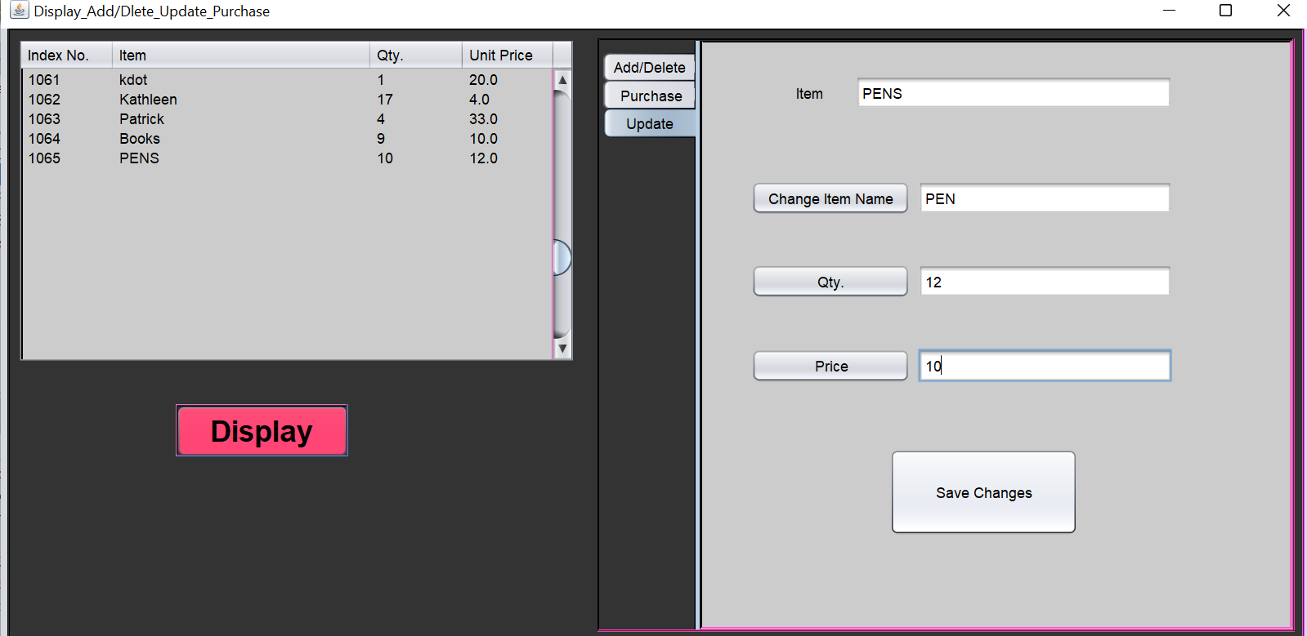

**DESCRIPTION:**

The edit profile form is added to the Stock management system to increase the system reusability and maintainability of the system. This form consists of four jlabel and four text field. The labels are Item, quantity, price and item name. The appropriate values should be filled in the text field to update the stock. It consists of two jbuttons.

**RESULT:**

Thus, the Stock maintenance system was tested for increasing the testability and maintainability by including the edit stock form.

|  |  |
| --- | --- |
| EX No: 14 Date: 29/11/22 | **IMPLEMENT THE MODIFIED SYSTEM AND TEST IT FOR VARIOUS SCENERIOS.** |

**AIM:**

To implement the modified Stock maintenance system and test it for various scenarios.

**UPDATE FORM:**



**DESCRIPTION:**

The values of the text field is given. On click of the save changes button, the values in the database will be changed to the appropriate text field values.

**RESULT:**

Thus, the improved and modified Stock maintenance system was implemented and tested for various test case scenarios.

**CONCLUSION**:

Thus, the project for the stock maintenance system was executed, code are generated and completed successfully.